Reception Home Learning
Week Beginning: 15.6.20
Reception
Daily Do’s
Counting & Remembered Facts: doubles and halves to 10. Number bonds to 10.
- Cymraeg: Scan the QR code for this week’s Welsh games. Also look at Pennard Primary’s Twitter page for more
Welsh games.
- Tricky words (Practice reading your level words-if applicable) PPT in (Hwb files - see resources section below)
The Tiger Who Came to Tea
Monday | Maths  Shape hunt powerpoint  shape hunt tally  (Hwb files) | Literacy  Listen to the story ‘My Dad’. Draw a picture of your dad and write sentences to describe him.  (Hwb files) | Active  Ball skills – throwing and catching, bouncing  (Hwb files)
Tuesday | Maths  Make a chart on jit5 to show a pictogram of yesterdays tally  (Hwb files) | Literacy  My Dad’s superpowers (Hwb files) | Creative  Make a Father’s Day Card – I love you to the moon and back card (Hwb files)
Wednesday | Maths  2D shape sort  (Hwb files) | Literacy  Interview your dad to find out the answers about your dad’s favourite things. (Hwb files) | DCF/ Outdoor learning  Capture nature’s beauty with a photograph.  (Hwb files)
Thursday | Maths  2d shape cut and stick  (Hwb files) | Literacy  Bug club story 2 and click the ‘bugs’ to answer questio | PSE  My hero. (Hwb files)
Friday | Maths  Play shape patterns games  https://www.topmarks.co.uk/ordering-and-sequencing/shape-patterns | Literacy  Bug club story 2 and click the ‘bugs’ to answer questions | Cookery  Make Balloon pop cakes as a gift for Father’s day (Hwb files)
Resources | Literacy Reading, Grammar & Spelling - https://www.activelearnprimary.co.uk/start  Tricky Words, creative, Active, Literacy – Follow the pathway below.  Hwb J2e my files shared files Reception Home Learning week 1

Reception Home Learning
Instructions
Daily Do’s – Counting & Remembered facts Each day spend 5-10 minutes on these counting targets.
Please use the 100 square I have shared with you in the folder if you need it. I have also shared the PowerPoint we
sometimes use in class to help if you find it useful.
Cymraeg Scan the QR code which will lead you to Quizlet where you can
practice and play games based on these Welsh patterns.

Tricky Words Spend some time each day to go over the words you are learning at the
Moment. Please move on when you are confident and can read the words out of
order too. I have included a PowerPoint for you to use if you wish. You can also play different games such as
snap/matching pairs/hunt the word

Once you are logged in, select the ‘My stuff’ tab and click on the abacus icon to find the maths work I have sent to you.
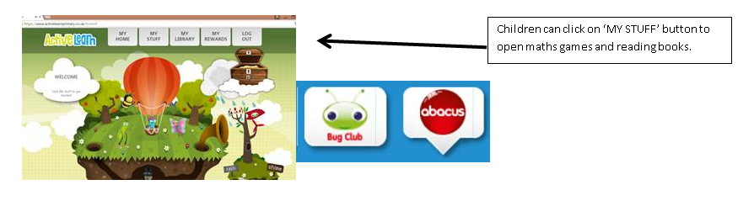

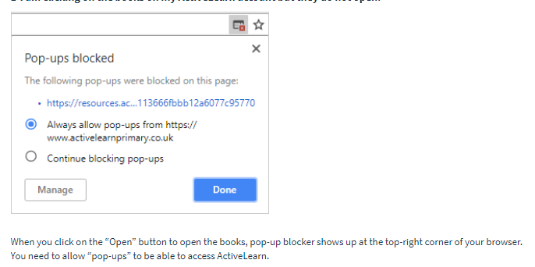
You will find maths games, activities and sometimes videos. For the main maths focus there are 4 different levels – support/core/extend/challenge. Please choose the appropriate level and challenge yourself to move to the next level the following day. For the interactive games you need to move through the levels – Bronze, Silver and gold. Once completed a level it will then unlock the next one. Sometimes there will be worksheets to complete. These can be printed, or you could have it up on screen and record on paper.
After completing your activities, you will win tokens which you can spend in the games zones.
If you have trouble launching the activities, check your pop up blocker is switched off

Literacy Reading– Again you will need to access the reading books I send you through Active learn. This time go to the ‘My stuff’ tab and select the ‘Bug Club’ icon. You will see a list of books that I would like you to read. To open a book just click and it will open on your computer screen. Throughout the book are ‘bugs’ to click on and answer some questions to earn points. When the bug is answered return to the book to complete it. At the end of the book you will be able to see if all bugs have been answered and then asked to add a smiley face depending on whether you enjoyed it or not.
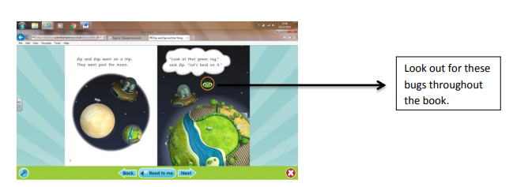

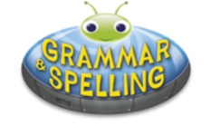
Literacy Grammar & Spelling This time click the Grammar & Spelling bug.
In this tab there may be a video to watch to explain a spelling rule and then games to play that are based on grammar or spelling strategies.
Maths – This week is all about shapes! You will be going on a shape hunt to see what objects you can find that are square, rectangle, circular etc. You will then make a tally and a chart to show how many of each shape you have found. You will also be cutting out and sorting shapes depending on how many sides they have got. And there is a really fun game on top marks for the end of the week.

Literacy – The story this week is called ‘My Dad’. On Sunday it is Father’s day so this week you will be writing about how wonderful your dad’s are. On Wednesday you will need to interview your dad or granddad to find out all about their favourite things.

Creative – Follow the powerpoint and instructions to make a rocket card for Father’s day.

Cookery – A gift for your dad!! Follow the recipe to make thses delicious Cake pops! Yum Yum.

PSE – Who is you’re hero? Why do you like them? What have they achieved? I would like you to draw a picture of them and write their name.

Outdoor learning – Capture natures beauty this week with your camera, i-pad or ask if you can borrow mum or dad’s phone to take a photo. Find something that you think is really beautiful – maybe a flower, a bug, a colourful leaf. The list is endless!! Have a look for ideas that I have given you in your hwb folder.

Active – Ball skills. With a partner you can practise throwing and catching. Use the guidance sheet that I have given you. If you want to practise by yourself then you can see how many times you can bounce a ball or throw a ball against the wall and catch it.

