Reception Home Learning
Week Beginning: 22.6.20
Reception
Daily Do’s
Counting & Remembered Facts: counting on and back to 20, counting in 2’s, counting in 10’s
- Cymraeg: Scan the QR code for this week’s Welsh games. Also look at Pennard Primary’s Twitter page for more
Welsh games.
- Tricky words (Practice reading your level words-if applicable) PPT in (Hwb files - see resources section below)

Mor Hyfryd Yw’r Byd – What a wonderful world
The very hungry caterpillar

Monday | Maths/ Outdoor learning  Outdoor symmetry task  (Hwb files) | Literacy - click the link to listen to the story  https://www.youtube.com/watch?v=75NQK-Sm1YY  The very hungry caterpillar –Listen to the story, make a hungry caterpillar to feed and retell the story using props.  (Hwb files) | Active  Cosmic Yoga  The very hungry caterpillar  https://www.youtube.com/watch?v=xhWDiQRrC1Y&t=31s
Tuesday | Maths  Symmetrical butterfly task  (Hwb files) | Literacy  The very Hungry Caterpillar sentence completion. (Hwb files) | Creative – Listen to Mrs Burgess reading Mor Hyfryd yw’r byd  Mor hyfryd yw’r byd creative task  (Hwb files)
Wednesday | Maths  Symmetrical or not symmetrical task  (Hwb files) | Literacy  The Very hungry caterpillar – Fix the sentence (Hwb files) | Science  Life cycle of a butterfly.  (Hwb files)
Thursday | Maths  Top marks games  https://www.topmarks.co.uk/symmetry/symmetry-matching | Literacy  Bug club story 2 and click the ‘bugs’ to answer questions (See Active Learn – My stuff) | PSE  Recipe for being a good friend.  . (Hwb files)
Friday | Maths  Explore symmetry with paint (Hwb files) | Literacy  Bug club story 2 and click the ‘bugs’ to answer questions(See Active Learn – My stuff) | DCF  Online safety at home – Lesson 1 ‘Jessie and Friends’  (Hwb files)
Resources | Literacy Reading, Grammar & Spelling - https://www.activelearnprimary.co.uk/start  Tricky Words, creative, Active, Literacy – Follow the pathway below.  Hwb J2e my files shared files Reception Home Learning week 1

Reception Home Learning
Instructions
Daily Do’s – Counting & Remembered facts Each day spend 5-10 minutes on these counting targets.
Please use the 100 square I have shared with you in the folder if you need it. I have also shared the PowerPoint we
sometimes use in class to help if you find it useful.
Cymraeg Scan the QR code which will lead you to Quizlet where you can
practice and play games based on these Welsh patterns.

Tricky Words Spend some time each day to go over the words you are learning at the
Moment. Please move on when you are confident and can read the words out of
order too. I have included a PowerPoint for you to use if you wish. You can also play different games such as
snap/matching pairs/hunt the word

Once you are logged in, select the ‘My stuff’ tab and click on the abacus icon to find the maths work I have sent to you.
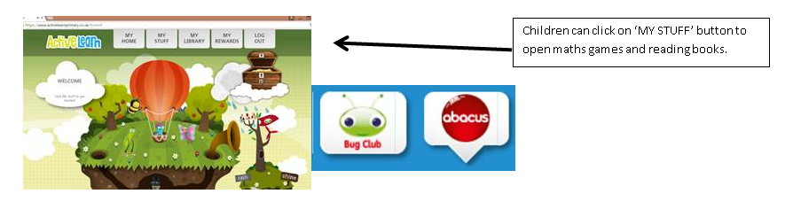

You will find maths games, activities and sometimes videos. For the main maths focus there are 4 different levels – support/core/extend/challenge. Please choose the appropriate level and challenge yourself to move to the next level the following day. For the interactive games you need to move through the levels – Bronze, Silver and gold. Once completed a level it will then unlock the next one. Sometimes there will be worksheets to complete. These can be printed, or you could have it up on screen and record on paper.
After completing your activities, you will win tokens which you can spend in the games zones.
If you have trouble launching the activities, check your pop up blocker is switched off

Literacy Reading– Again you will need to access the reading books I send you through Active learn. This time go to the ‘My stuff’ tab and select the ‘Bug Club’ icon. You will see a list of books that I would like you to read. To open a book just click and it will open on your computer screen. Throughout the book are ‘bugs’ to click on and answer some questions to earn points. When the bug is answered return to the book to complete it. At the end of the book you will be able to see if all bugs have been answered and then asked to add a smiley face depending on whether you enjoyed it or not.
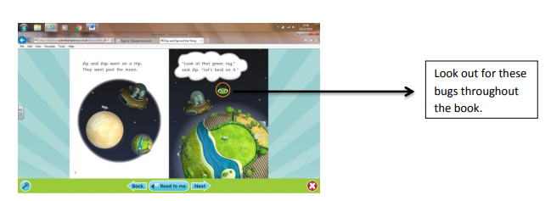

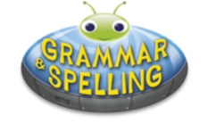
Literacy Grammar & Spelling This time click the Grammar & Spelling bug.
In this tab there may be a video to watch to explain a spelling rule and then games to play that are based on grammar or spelling strategies.
Maths – This week the theme is symmetry. We did a bit of work on this in the Autumn term when we chalked shapes out on the yard and used objects to make them the same both sides. This week you will be starting off outdoors to see what things in nature are symmetrical. There are loads! If you are not sure what if something is symmetrical then you can put a mirror down the middle, look in the reflection to check it looks the same. What a clever trick! You will be exploring symmetry through lots of multisensory ways this week and you will even get to make a beautiful butterfly just like the one from the story ‘The very hungry caterpillar’

Literacy – The very hungry caterpillar is the theme for this week. Click on the link https://www.youtube.com/watch?v=75NQK-Sm1YY to watch a video of the story or you can listen to me read you the story – you will find this in your Hwb folder. I would like you to retell the story this week. To start with you will need to make a caterpillar (instructions are in your hwb file), cut out the food and retell the story by feeding the foods to the caterpillar .You have also been given some sentence work this week. One of the activities you need to fill in the missing word to complete the sentence and the other activity is to correct the spelling mistakes and find the missing capital letters and full stops. I have also given you an extension task if you are looking for a challenge this week. In your hwb folder you will find a diary for each day of the week. Draw and write what the caterpillar has to eat on each day.
Creative – Mrs Burgess has recorded a story for you this week ‘Mor Hyfryd yw’r byd’ – ‘What a wonderful world’. Swansea is a wonderful part of the world so your challenge this week is to create a model of your favourite place in swansea. See the information sheet in your hwb folder for some ideas.
PSE – We are all missing our friends a lot. This week you will be making a friendship potion. What do you think makes a good friend? Being kind? Caring? Funny? You decide what qualities make a good friend. Have a look at the powerpoint before you begin.
SCIENCE – The life cycle of a butterfly. If you have listened to the story ‘The very hungry caterpillar’ you will easily be able to complete this activity. Print out the activity from your hwb file and sequence the stages of the life cycle.
Active – A fab Cosmic Yoga this week – all about the very hungry caterpillar. Click the link https://www.youtube.com/watch?v=xhWDiQRrC1Y&t=31s
DCF – We are using technology a lot more at home due to the way in which we are learning at the moment. It is important that we know how to stay safe online - Lesson 1 ‘Jessie and friends’. Instructions are provided in your hwb folder. There is a lovely short video for you to watch.

