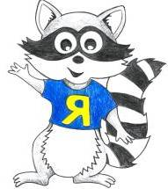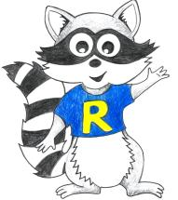Reception Home Learning
Week Beginning: 29.6.20
Reception
Daily Do’s
Counting & Remembered Facts: counting on and back to 20, counting in 2’s, counting in 10’s
- Cymraeg: Scan the QR code for this week’s Welsh games. Also look at Pennard Primary’s Twitter page for more
Welsh games.
- Tricky words (Practice reading your level words-if applicable) PPT in (Hwb files - see resources section below)

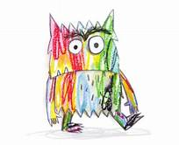The colour Monster

Monday | Maths – Addition  (Hwb files) | Literacy - Listen to the story ‘The Colour Monster’  Draw each monster and write a sentence about it.  (Hwb files) | Active – Cosmic Dance Party  https://youtu.be/23VdtT0vQUY
Tuesday | Maths - Subtraction  (Hwb files) | Literacy – Create your own colour monster. What feeling does it represent. | Creative – Mood Painting  (Hwb files)
Wednesday | Top marks game - addition  https://www.topmarks.co.uk/addition/addition-to-10 | Literacy Watch Moz the Monster. click link for video clip stimulus https://www.literacyshed.com/moz.html. Think of words to describe Moz  (Hwb files) | Outdoor Learning – Make a den for a monster  (Hwb files)
Thursday | Maths  Top marks game – subtraction  https://www.topmarks.co.uk/subtraction/subtraction-to-10 | Literacy  Bug club story 2 and click the ‘bugs’ to answer questions(See Active Learn – My stuff) | PSE- Happy, sad and angry picture sort  . (Hwb files)
Friday | Maths – Word problems.  (Hwb files) | Literacy  Bug club story 2 and click the ‘bugs’ to answer questions(See Active Learn – My stuff) | DCF  Online safety at home – Jessie and Friends Lesson 2  (Hwb files)
Resources | Literacy Reading, Grammar & Spelling - https://www.activelearnprimary.co.uk/start  Tricky Words, creative, Active, Literacy – Follow the pathway below.  Hwb J2e my files shared files Reception Home Learning week 1

Reception Home Learning
Instructions
Daily Do’s – Counting & Remembered facts Each day spend 5-10 minutes on these counting targets.
Please use the 100 square I have shared with you in the folder if you need it. I have also shared the PowerPoint we
sometimes use in class to help if you find it useful.
Cymraeg Scan the QR code which will lead you to Quizlet where you can
practice and play games based on these Welsh patterns.

Tricky Words Spend some time each day to go over the words you are learning at the
Moment. Please move on when you are confident and can read the words out of
order too. I have included a PowerPoint for you to use if you wish. You can also play different games such as
snap/matching pairs/hunt the word

Once you are logged in, select the ‘My stuff’ tab and click on the abacus icon to find the maths work I have sent to you.
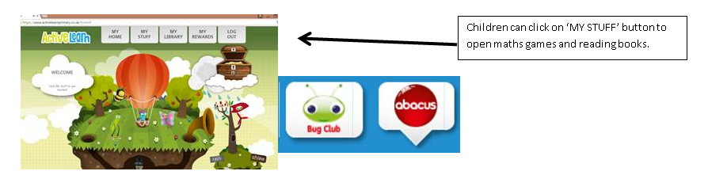

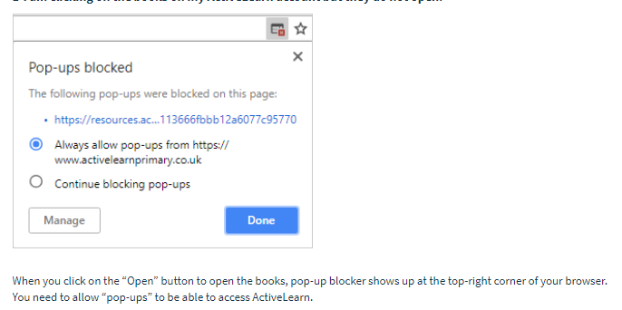You will find maths games, activities and sometimes videos. For the main maths focus there are 4 different levels – support/core/extend/challenge. Please choose the appropriate level and challenge yourself to move to the next level the following day. For the interactive games you need to move through the levels – Bronze, Silver and gold. Once completed a level it will then unlock the next one. Sometimes there will be worksheets to complete. These can be printed, or you could have it up on screen and record on paper.
After completing your activities, you will win tokens which you can spend in the games zones.
If you have trouble launching the activities, check your pop up blocker is switched off

Literacy Reading– Again you will need to access the reading books I send you through Active learn. This time go to the ‘My stuff’ tab and select the ‘Bug Club’ icon. You will see a list of books that I would like you to read. To open a book just click and it will open on your computer screen. Throughout the book are ‘bugs’ to click on and answer some questions to earn points. When the bug is answered return to the book to complete it. At the end of the book you will be able to see if all bugs have been answered and then asked to add a smiley face depending on whether you enjoyed it or not.
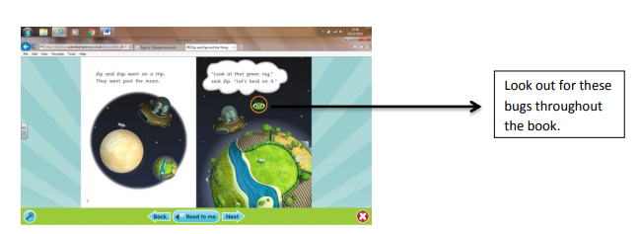

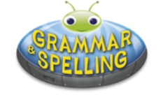
Literacy Grammar & Spelling This time click the Grammar & Spelling bug.
In this tab there may be a video to watch to explain a spelling rule and then games to play that are based on grammar or spelling strategies.
Maths – This week we are revisiting some of the work we have previously covered – addition, subtraction and problem solving. Use the numicon or numberlines that I have previously sent you if you need a little bit of help.

Literacy – It’s all about monsters this week! On Monday listen to the story that I have read for you ‘The colour monster’. Each monster is a different colour and has a different emotion. Choose 2 of the monsters to draw and write a sentence about. Remember to FRED talk each word.
On Tuesday think about what colours are missing from the story. Create your own colour monster e.g purple monster and think which emotion it represents.
Wednesday – Click on the link to watch a short video clip. You might have seen this advert on the tv last Christmas. It is about a little boy and a very friendly monster called Moz. In your hwb folder you have got a picture of Moz. Can you think of words to describe him?
Creative – This is such an interesting activity to do. Do you think music can change the way we feel? Listen to each piece of music and let it influence what you paint. Does the music make you feel happy, sad, angry, excited? You decide!
PSE – Can you identify the happy, sad and angry faces. Cut them out and sort into groups.
Active – Click the link for a dance yoga session.
DCF – We are using technology a lot more at home due to the way in which we are learning at the moment. It is important that we know how to stay safe online - Lesson 2 ‘Jessie and friends’. Instructions are provided in your hwb folder
Outdoor learning – Making den’s are so much fun. This week you can make a den for one of the monsters from the story. You can choose to make an indoor den or an outdoor den depending on the weather!

