Reception Home Learning
Week Beginning: 6.7.20
Reception
Daily Do’s
Counting & Remembered Facts: Doubles and halves to 10. Addition and subtraction to 10
- Cymraeg: Scan the QR code for this week’s Welsh games. Also look at Pennard Primary’s Twitter page for more
Welsh games.
- Tricky words (Practice reading your level words-if applicable) PPT in (Hwb files - see resources section below)
Story – ‘Beegu’

Monday | Maths – Counting in 2’s  (hwb files)  https://www.bbc.co.uk/bitesize/articles/zkjv382  Counting in 2’s activity  (Hwb files) | Literacy -Listen to the story Beegu. Answer questions about the story  (Hwb files) | Active –Journey to the moon  https://www.bbc.co.uk/programmes/b03g6vs2
Tuesday | Maths – Counting in 10’s  https://www.bbc.co.uk/bitesize/articles/z6dr92p  Counting in 10s maze activity  (Hwb files) | Literacy – Pretend to be Beegu – write a postcard to your friends on the moon. | Creative – Make a paper plate spaceship for Beegu to return home  (Hwb files)
Wednesday | Maths – Reading number words bingo  (Hwb files) | Literacy – What I would take with me to the moon  (Hwb files) | Cooking – Rock cakes  (Hwb files)
Thursday | Maths – Counting on and find a number between..  .https://www.topmarks.co.uk/learning-to-count/blast-off | Literacy  Bug club story 2 and click the ‘bugs’ to answer questions(See Active Learn – My stuff) | Health and well being-  Have you filled your bucket today? – Click on link to watch video  https://www.youtube.com/watch?v=JEg38zCOMgk  Draw how you have filled your bucket today  . (Hwb files)
Friday | Maths –  Let’s see how much you can remember over the last few weeks!  Reception Challenge questions  (Hwb files) | Literacy  Bug club story 2 and click the ‘bugs’ to answer questions(See Active Learn – My stuff) | DCF  Online safety at home – Jessie’s feelings  Lesson 3  www.thinkuknow.co.uk/parents/jessie-and-friends/  (Hwb files)
Resources | Literacy Reading, Grammar & Spelling - https://www.activelearnprimary.co.uk/start  Tricky Words, creative, Active, Literacy – Follow the pathway below.  Hwb J2e my files shared files Reception Home Learning week 1

Reception Home Learning
Instructions
Daily Do’s – Counting & Remembered facts Each day spend 5-10 minutes on these counting targets.
Please use the 100 square I have shared with you in the folder if you need it. I have also shared the PowerPoint we
sometimes use in class to help if you find it useful.
Cymraeg Scan the QR code which will lead you to Quizlet where you can
practice and play games based on these Welsh patterns.

Tricky Words Spend some time each day to go over the words you are learning at the
Moment. Please move on when you are confident and can read the words out of
order too. I have included a PowerPoint for you to use if you wish. You can also play different games such as
snap/matching pairs/hunt the word

Once you are logged in, select the ‘My stuff’ tab and click on the abacus icon to find the maths work I have sent to you.
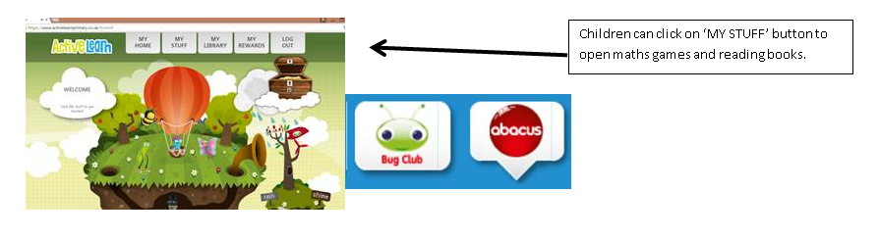

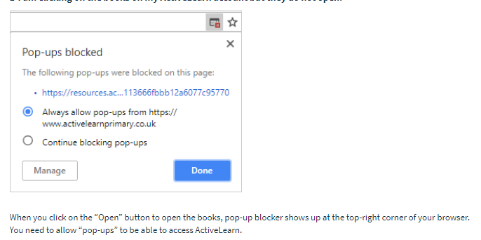
You will find maths games, activities and sometimes videos. For the main maths focus there are 4 different levels – support/core/extend/challenge. Please choose the appropriate level and challenge yourself to move to the next level the following day. For the interactive games you need to move through the levels – Bronze, Silver and gold. Once completed a level it will then unlock the next one. Sometimes there will be worksheets to complete. These can be printed, or you could have it up on screen and record on paper.
After completing your activities, you will win tokens which you can spend in the games zones.
If you have trouble launching the activities, check your pop up blocker is switched off

Literacy Reading– Again you will need to access the reading books I send you through Active learn. This time go to the ‘My stuff’ tab and select the ‘Bug Club’ icon. You will see a list of books that I would like you to read. To open a book just click and it will open on your computer screen. Throughout the book are ‘bugs’ to click on and answer some questions to earn points. When the bug is answered return to the book to complete it. At the end of the book you will be able to see if all bugs have been answered and then asked to add a smiley face depending on whether you enjoyed it or not.
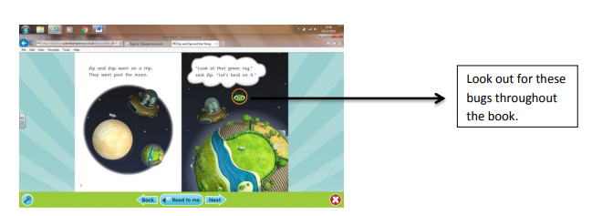

Literacy Grammar & Spelling This time click the Grammar & Spelling bug.
In this tab there may be a video to watch to explain a spelling rule and then games to play that are based on grammar or spelling strategies.
Maths – This week you will be counting in 2’s and 10. Click on the link to see videos to help you learn this then go to your hwb folder to print out the activity sheets.
On Wednesday you will be learning number words from one to ten. This is quite a tricky one and a few hard words to recognise. Keep working on these throughout the week. Maybe use them on flashcards or play matching pairs to help you remember. On Thursday you have a top marks game to reinforce number skills and on Friday I have made an activity sheet to see how much you can remember from this term! Try to do it by yourself!

Literacy – Our story this week is Beegu. It is about a little Alien who is lost and has found himself on planet Earth. Listen to the story first then complete the comprehension questions. Decide if each sentence is true or false. You will also be writing a postcard this week. Pretend that you are Beegu. Tell your friends back on the moon what it is like to be on Earth. On Wednesday have a think about 10 things you would take to the moon!

Creative – Follow the instructions in your hwb folder to make a space craft fro Beegu to go home.
PSE – Have you filled your bucket this week? Listen to the story by clicking on the link. Think about how you can fill your bucket with kindness. Draw on your bucket ways that you have filled it this week.
Active – Click on the link to take you to bbc school radio where you will begin your journey to the moon.
Cooking – I bet Beegu misses his favourite food from the moon ‘Rock Cakes’. Follow the recipe to make them!
DCF – Lession 3 of using the internet safely at home. Jessie’s Feelings. Click on the link to watch last week’s video again then go to your hwb folder to see the instructions for this week’s activity.

