Year 1 Home Learning
Week Beginning: 8.6.20
Reception
Daily Do’s
Counting & Remembered Facts: counting on and back to 20. 1 more and 1 less to 10, addition and subtraction mental calculations to 10.
- Cymraeg: Scan the QR code for this week’s Welsh games. Also look at Pennard Primary’s Twitter page for more
Welsh games.
- Tricky words (Practice reading your level words-if applicable) PPT in (Hwb files - see resources section below)
The Tiger Who Came to Tea
Monday | Maths  Measuring height – shortest to tallest tigers (Hwb files) | Literacy  Listen to the story ‘The Tiger Who Came to Tea’  Complete the storyboard. Write sentences to match the main parts of the story. (Hwb files) | Creative  Look at the Henri Rousseau PowerPoint  Study the painting ‘Tiger in a tropical storm’ and answer the questions (Hwb files)
Tuesday | Maths  Measuring Capacity – full or empty (Hwb files) | Literacy  Look at ‘The Tiger Who Came to Tea’ PowerPoint – focus on the speech bubbles  Complete the character speech bubble activity  * think of how the characters feel  *think of what the characters may say | Creative  Create your own ‘Tiger in a tropical storm’ in the style of Henri Rousseau
Wednesday | Maths  Measuring weight – choose 3 objects and draw pictures to show heaviest to lightest. You could use a weighing scale to check. (Hwb files) | Literacy  Write invitations to your tea party (Hwb files) | Tea party planning  (Hwb files)
Thursday | Maths  Top marks maths – measures  https://www.topmarks.co.uk/early-years/lets-compare | Literacy  Bug club story 1 and click the ‘bugs’ to answer questions | Active  Fitness trail (Hwb files)
Friday | Maths  Number bonds to 10 – colour by numbers (Hwb files) | Literacy  Bug club story 2 and click the ‘bugs’ to answer questions | Tea party
Resources | Literacy Reading, Grammar & Spelling - https://www.activelearnprimary.co.uk/start  Tricky Words, creative, Active, Literacy – Follow the pathway below.  Hwb J2e my files shared files Reception Home Learning week 1

Reception Home Learning
Instructions
Daily Do’s – Counting & Remembered facts Each day spend 5-10 minutes on these counting targets.
Please use the 100 square I have shared with you in the folder if you need it. I have also shared the PowerPoint we
sometimes use in class to help if you find it useful.
Cymraeg Scan the QR code which will lead you to Quizlet where you can
practice and play games based on these Welsh patterns.

Tricky Words Spend some time each day to go over the words you are learning at the
Moment. Please move on when you are confident and can read the words out of
order too. I have included a PowerPoint for you to use if you wish. You can also play different games such as
snap/matching pairs/hunt the word

Once you are logged in, select the ‘My stuff’ tab and click on the abacus icon to find the maths work I have sent to you.

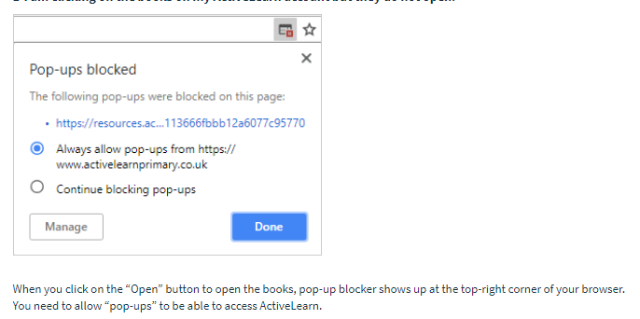
You will find maths games, activities and sometimes videos. For the main maths focus there are 4 different levels – support/core/extend/challenge. Please choose the appropriate level and challenge yourself to move to the next level the following day. For the interactive games you need to move through the levels – Bronze, Silver and gold. Once completed a level it will then unlock the next one. Sometimes there will be worksheets to complete. These can be printed, or you could have it up on screen and record on paper.
After completing your activities, you will win tokens which you can spend in the games zones.
If you have trouble launching the activities, check your pop up blocker is switched off

Literacy Reading– Again you will need to access the reading books I send you through Active learn. This time go to the ‘My stuff’ tab and select the ‘Bug Club’ icon. You will see a list of books that I would like you to read. To open a book just click and it will open on your computer screen. Throughout the book are ‘bugs’ to click on and answer some questions to earn points. When the bug is answered return to the book to complete it. At the end of the book you will be able to see if all bugs have been answered and then asked to add a smiley face depending on whether you enjoyed it or not.
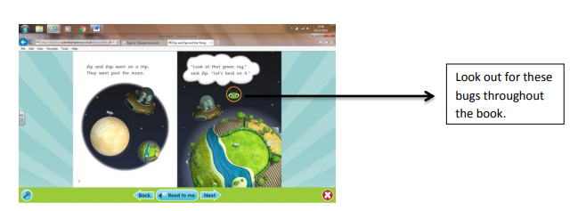

Literacy Grammar & Spelling This time click the Grammar & Spelling bug.
In this tab there may be a video to watch to explain a spelling rule and then games to play that are based on grammar or spelling strategies.
Maths – This week our theme is measures. You will be measuring height, weight and capacity using non standard measures. You will order the heights of the tigers and put them in order from shortest to tallest. If you want an extra challenge you could measure how many blocks tall each tiger is.
On Tuesday you will be measuring capacity. Have a look at the powerpoint that I have given you. Look around your house to find some different size and shape containers – you can use bottles, cups, yoghurt pots, jam jars etc. Fill up your sink or bath and explore making them full, half full or empty.
On Wednesday you will be measuring weight – choose 3 objects from around your house. Hold them in your hands and decide which one is the heaviest and the lightest. Print out the measuring weight worksheet and draw pictures of the objects and order them from heaviest to lightest.
On Thursday go to https://www.topmarks.co.uk/early-years/lets-compare to play the measurements games
On Friday you’ve got number bonds colour by numbers. Get someone to test you to see how many you can remember!

Literacy – I love this story ‘The Tiger who came to tea’ All of our activities are based on this book and will lead up to a tea party at the end of the week that you are going to organise! First listen to the story. On Monday I would like you to cut out the pictures that tell the story and put them in the right order. You can then write a sentence for each picture. Remember to FRED TALK words that you are not sure of. Tuesday you have got some speech bubbles. I want you to choose your favourite character and think about what that person might be saying. Write inside the speech bubbles. Don’t forget to use ‘up the hill’. On Wednesday think about who you are going to invite to your party. Print out the invitations and write them. Thursday and Friday you have got your bug club reading books. Go to active learn then my stuff to find them.

Creative – Look at the Henri Rousseau powerpoint. Study the painting ‘Tiger in a tropical storm’ and answer the questions then have a go at creating your own ‘Tiger in a tropical storm’ painting. I would love to see your work so please take a photograph and upload it to your Hwb folder.

Tea party planning – Now is your chance to plan your very own tea party. You’ve already written the invitations! You can colour in some bunting to decorate your house, decide which party games to play, make a shopping list for what food you need to buy, make some party food. I would love to see photographs of your party!
Fitness Trail -

