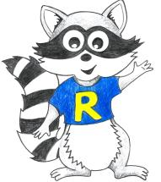
Reception Home Learning
Week Beginning: 11.5.20
Please scroll down to bottom of pages for additional information on lessons
Reception
Daily Do’s - 10 minutes each
- Counting & Remembered Facts: doubles and halves to 10, count on in 1’s to 20, count back from 20, 1 more/ less than a number to 10
- Tricky words – See shared file on Hwb. Please work on your current level and when ready progress to the next.
- Cymraeg - please scan the QR code below

Monday | - Maths: Coin recognition Powerpoint and coin recognition activity (See Hwb- my files)  - Literacy Reading: Bug club story and click the ‘bugs’ to answer questions (Active Learn – My stuff)  - Active: Cosmic Yoga https://www.youtube.com/watch?v=xhWDiQRrC1Y
Tuesday | - Maths: watch bbc bitesize https://www.bbc.co.uk/bitesize/clips/z8f34wx. Play Top marks game https://www.topmarks.co.uk/money/toy-shop-money  - Literacy Reading: Bug club story and click the ‘bugs’ to answer questions (Active learn – My stuff)  - Time Capsule: See time capsule information sheet ( See Hwb folder)
Wednesday | - Maths: Play money bingo – (see Hwb folder)  - Literacy/ Creative: Listen to the story ‘The bog baby’ https://www.youtube.com/watch?v=nVuH4BdVQOQ  See Bog Baby task (See Hwb folder)  - DCF: Draw a picture of The Bog Baby using JIT5 Paint.
Thursday | - Maths: Set up a shop at home to buy items using coins  - Literacy: Continue Bog Baby task (See Hwb Folder)  - Outdoor learning: Minibeast hunt (See Hwb folder)
Friday | - Maths: How much money in my piggy bank (See Hwb folder)  - Literacy Oracy: Video Record Bog Baby descriptions.  - Science: Life Cycle of a frog (See Hwb folder)

Reception Home Learning
Instructions
Daily Do’s – Counting & Remembered facts Each day spend 5-10 minutes on these counting targets.
Cymraeg Scan the QR code which will lead you to Quizlet where you can
practice and play games based on these Welsh patterns.

Tricky Words Spend some time each day to go over the words you are learning at the
Moment. Please move on when you are confident and can read the words out of

order too. I have included a PowerPoint for you to use if you wish. You can also play different games such as snap/matching pairs/hunt the word

Literacy/ creative- This week I have given you one of my favourite stories ‘The Bog Baby’. You can click on the link to watch a short video of this story or if you prefer I have saved the story in your Hwb folder on a powerpoint. Ask a grown up to read it to you. The task for this week is linked to creative development. I would like you to create your own Bog Baby. Remember to make it different to the one in the story! When you have done that ask an adult to record you describing your Bog Baby and then send me the video! Instructions are on the Bog Baby information sheet.
Maths – The theme for this week is money. I have included some activities in your Hwb folder and a BBC bitesize video for you to watch and a game to play. Click on the links above (Tuesday)
Science – Life cycle of a frog. It is so interesting how a tadpole changes into a frog! I have included a powerpoint and a short activity for you to complete the life cycle of a frog.
Active- As our theme is minibeasts this week. I have given you another cosmic yoga. This time it is the story of ‘The very hungry caterpillar’.
Outdoor Learning – This week I would like you to go on a minibeast hunt. Before you set off have a look at the minibeasts PowerPoint which I have saved in the shared folder on Hwb? Can you name them? With an adult go on a minibeast hunt. This could be during a daily walk with your family or even in your garden. I have provided a sheet to complete. I wonder how many minibeasts you will find? If the weather is not too good on this day, then please complete when possible.
DCF – Draw a picture of the Bog Baby. Log in to Hwb, select Just2easy,select JIT5, Select ‘paint’ on the top bar. Remember to give your file a name and save it.

Time capsule – This difficult time is a moment in history for us all. I have given you an information sheet on how to make a time capsule so that in years to come this period of time can be shared with others!

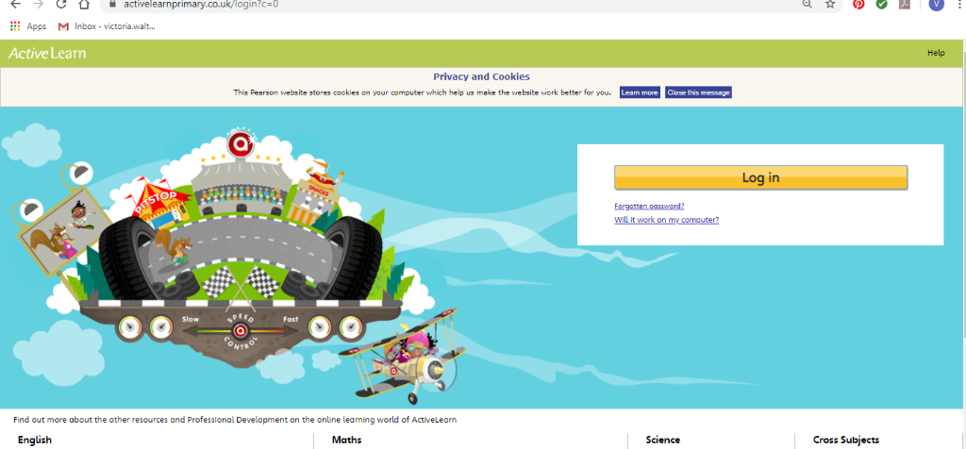Active learn Maths – You will need to Log in to Active Learn to access the maths learning. Google Active Learn Primary then you can Log in to access your account. Your username and password were included in the Home Learning booklet sent out when school finished. If you are unable to find this, plea se let me know.

Once you are logged in, select the ‘My stuff’ tab and click on the abacus icon to find the maths work I have sent to you.
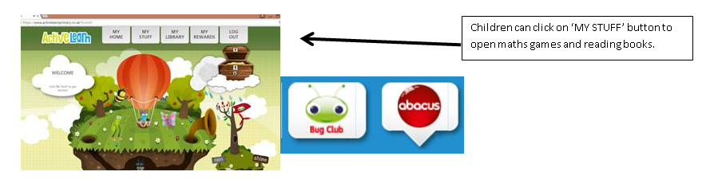
You will find maths games, activities and sometimes videos. For the main maths focus there are 4 different levels – support/core/extend/challenge. Please choose the appropriate level and challenge yourself to move to the next level the following day. For the interactive games you need to move through the levels – Bronze, Silver and gold. Once completed a level it will then unlock the next one. Sometimes there will be worksheets to complete. These can be printed, or you could have it up on screen and record on paper.
After completing your activities, you will win tokens which you can spend in the games zones.

Literacy Reading ‘Bug Club’ – Again you will need to access the reading books I send you through Active learn. This time go to the ‘My stuff’ tab and select the ‘Bug Club’ icon. You will see a list of books that I would like you to read. To open a book just click and it will open on your computer screen. Throughout the book are ‘bugs’ to click on and answer some questions to earn points. When the bug is answered return to the book to complete it. At the end of the book you will be able to see if all bugs have been answered and then asked to add a smiley face depending on whether you enjoyed it or not.
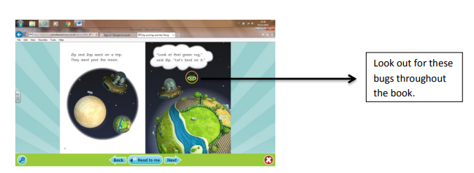

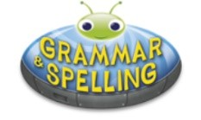
Literacy Grammar & Spelling This time click the Grammar & Spelling bug.
In this tab there may be a video to watch to explain a spelling rule and then games to play that are based on grammar or spelling strategies

