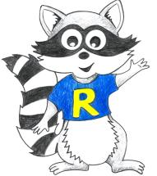
Reception Home Learning
Week Beginning: 1.6.20
Reception
Daily Do’s - 10 minutes each
- Counting & Remembered Facts: doubles and halves to 10, count on in 1’s to 20, count back from 20. Count in 2’s to 20, count in 10’s to 100, number bonds to 10
- Tricky words – See shared file on Hwb. Please work on your current level and when ready progress to the next.
- Cymraeg - please scan the QR code below

NATIONAL GARDEN WILDLIFE WEEK
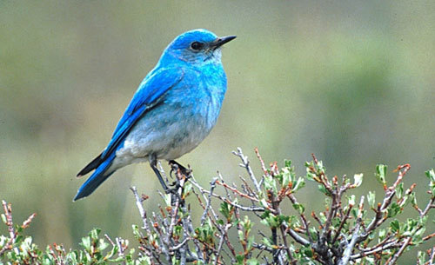

Monday | - Maths: Numicon addition(See Hwb –Just2easy - My Files)  - Literacy : Bug club story and click the ‘bugs’ to answer questions  - Science: Look at British bird powerpoint. Then go on RSPB website and select - Which bird song is that? https://www.rspb.org.uk/birds-and-wildlife/bird-songs/what-bird-is-that/  Complete ‘Which bird song is that?’ activity (See Hwb –Just2easy - My Files)
Tuesday | - Maths: Numicon 1 more 1 less (See Hwb –Just2easy - My Files)  - Literacy : Bug club story and click the ‘bugs’ to answer questions  - Outdoor learning: Bird counting tally (See Hwb –Just2easy - My Files)  - Health and well being – Listen to birdsong radio https://www.rspb.org.uk/get-involved/campaigning/let-nature-sing/birdsong-radio/ and complete a mindfulness colouring in of your choice.
Wednesday | - Maths: Numicon doubles to 10 (See Hwb –Just2easy - My Files)  - Literacy: British wildlife writing – Squirrel factsheet (See Hwb –Just2easy - My Files)  - Active :Cosmic yoga – Tallulah the owlet - https://www.youtube.com/watch?v=2aje33UPixE
Thursday | - Maths: Bee’s in the garden halving activity (Hwb – just2eay – My files)  - Literacy: British Wildlife writing – Hedgehog factsheet (See Hwb –Just2easy - My Files)  - DCF – using JIT5 paint a picture of your favourite wildlife animal (Just2easy – Jit5 – paint)
Friday | - Maths: Abacus – Sea Shack Smash (Active Learn – My stuff)  - Literacy: Read the story ‘The tale of two feathers’ (See Hwb –Just2easy - My Files) then answer the true/ false questions.  - Creative: Make a bird feeder craft (See Hwb –Just2easy - My Files)

Reception Home Learning
Instructions
Daily Do’s – Counting & Remembered facts Each day spend 5-10 minutes on these counting targets.
Cymraeg Scan the QR code which will lead you to Quizlet where you can
practice and play games based on these Welsh patterns.

Tricky Words Spend some time each day to go over the words you are learning at the
Moment. Please move on when you are confident and can read the words out of
order too. I have included a PowerPoint for you to use if you wish. You can also play different games such as snap/matching pairs/hunt the word
- Literacy – This week it is National Garden Wildlife week. To develop your knowledge about some garden wildlife I have included powerpoints about squirrels and hedgehogs. I would like you to read these with an adult and then make a fact sheet about each of these creatures. I have also given you a lovely story called ‘A tale of two feathers’ . Read the sentences and decide if each sentence is true or false. You will need to listen to the story carefully!
- Maths- We are working with Numicon this week. I have included a set of printable Numicon for you to print out at home to support your learning each day.
- Health & Well-Being – We all need some time now and again to completely relax and take our minds off any worries we might have. This activity will help you to relax your body and your mind. Click on the link for the RSPB birdsong radio. Listen to the relaxing sounds and choose a mindfulness colouring in sheet to complete. Remember to be neat and stay inside the lines!
- Science – Which birdsong is that? Every morning I love waking up to the sounds of the birds singing. I always wonder what they look like! Have a look at the British birds powerpoint I have given you then click on the link above (Monday) to hear the sounds each bird makes. Print out the which birdsong is it activity sheet and spend a little time during your daily walk listening out for each of the birds singing. You could record them on a phone or iPad if you want to.
- Active- We all love owls! Especially baby owls – Have a go at Tallulah the owlet Cosmic Yoga activity. Click on the link above to take you to it (Wednesday).
- Outdoor Learning – Bird counting tally. Go out into your garden or take on your daily walk. Have a good look to see how many of each type of bird you can find. You should be good at this now as you did this last week when counting Elmer’s colours!
- Art – Make a bird feeder craft. Follow the instructions that I have given you to make a bird feeder. You can put it out your garden to encourage more beautiful birds into your garden.
- DCF – Log in to Hwb – select just2easy – select jit5 – select paint. Choose your favourite garden wildlife creature to paint.

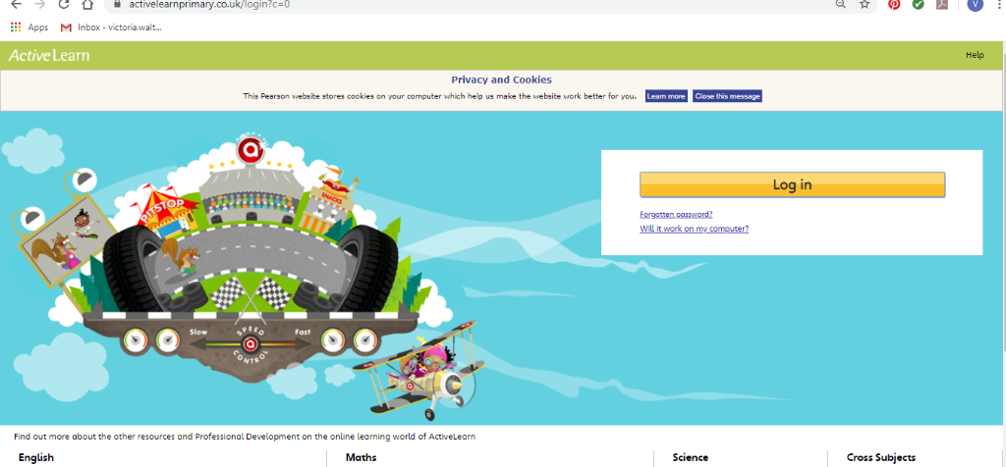Maths – You will need to Log in to Active Learn to access the maths learning. Google Active Learn Primary then you can Log in to access your account. Your username and password were included in the Home Learning booklet sent out when school finished. If you are unable to find this, plea se let me know.

Once you are logged in, select the ‘My stuff’ tab and click on the abacus icon to find the maths work I have sent to you.
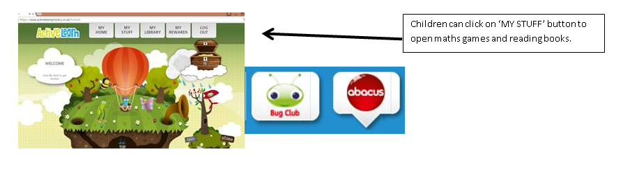
You will find maths games, activities and sometimes videos. For the main maths focus there are 4 different levels – support/core/extend/challenge. Please choose the appropriate level and challenge yourself to move to the next level the following day. For the interactive games you need to move through the levels – Bronze, Silver and gold. Once completed a level it will then unlock the next one. Sometimes there will be worksheets to complete. These can be printed, or you could have it up on screen and record on paper.
After completing your activities, you will win tokens which you can spend in the games zones.
Literacy Reading– Again you will need to access the reading books I send you through Active learn. This time go to the ‘My stuff’ tab and select the ‘Bug Club’ icon. You will see a list of books that I would like you to read. To open a book just click and it will open on your computer screen. Throughout the book are ‘bugs’ to click on and answer some questions to earn points. When the bug is answered return to the book to complete it. At the end of the book you will be able to see if all bugs have been answered and then asked to add a smiley face depending on whether you enjoyed it or not.
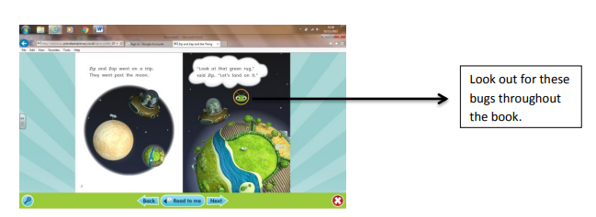

Literacy Grammar & Spelling This time click the Grammar & Spelling bug.
In this tab there may be a video to watch to explain a spelling rule and then games to play that are based on grammar or spelling strategies.

Parents - You can click the link to see a short video on the programmes available in JiT here https://www.j2e.com/help/videos/JIT

