Reception Home Learning
Week Beginning: 18.5.20

NATIONAL ELMER DAY – SAT 23RD MAY 2020 - Information sheet included in Hwb Folder.
Reception
Daily Do’s - 10 minutes each
- Counting & Remembered Facts: doubles and halves to 10, count on in 1’s to 20, count back from 20. Count in 2’s to 20, count in 10’s to 100
- Tricky words – See shared file on Hwb. Please work on your current level and when ready progress to the next.
- Cymraeg - please scan the QR code below

Monday | - Maths: Play Elmer colour collecting game (See Hwb –Just2easy - My Files)  - Literacy : Listen to the story ‘Elmer’ https://www.youtube.com/watch?v=XtY7KlOX-PE  Make a story map to retell the story  - Science: Experiment : Make a rainbow jar(See Hwb –Just2easy - My Files)
Tuesday | - Maths: Elmer tally chart(See Hwb –Just2easy - My Files)  - Literacy : Elmer book review(See Hwb –Just2easy - My Files)  - Outdoor learning: Frozen flowers sensory play (See Hwb –Just2easy - My Files)
Wednesday | - Maths: Repeated colour patterns(See Hwb –Just2easy - My Files)  - Literacy: Bug Club spelling and Grammar: The alphabet (Active Learn – My stuff)  - Health and Well being – We are all different powerpoint, story and activity(See Hwb –Just2easy - My Files)
Thursday | - Maths/ DCF: make a pictogram of Elmer’s colours: (Hwb – just2easy- Jit5- chart)  - Literacy: Bug club story and click the ‘bugs’ to answer questions (Active Learn – My stuff)  - Active: Jungle safari yoga https://www.youtube.com/watch?v=qMGn47lGm3U
Friday | - Maths: Elmer subtraction sheet (See Hwb –Just2easy - My Files)  - Literacy: Bug club story and click the ‘bugs’ to answer questions (Active Learn – My stuff)  - Creative: Milk bottle Elmer(See Hwb –Just2easy - My Files)

Reception Home Learning
Instructions
Daily Do’s – Counting & Remembered facts Each day spend 5-10 minutes on these counting targets.
Cymraeg Scan the QR code which will lead you to Quizlet where you can
practice and play games based on these Welsh patterns.

Tricky Words Spend some time each day to go over the words you are learning at the
Moment. Please move on when you are confident and can read the words out of
order too. I have included a PowerPoint for you to use if you wish. You can also play different games such as snap/matching pairs/hunt the word
- Literacy –On Saturday 23d May it is national Elmer day so this week our activities are based around this lovely story. Listen to the story using the link http://www.youtube.com/watch?v=abVx9_dPKg8
I would like you to then create a story map to retell the story. I have included a template for you to use or you can create your own like we do in school.
I would also like you to make a book review about the story Elmer. Decide if you liked it and what was your favourite part.
- Maths- our maths is all based around Elmer this week. Elmer is lots of different colours so this week we will be playing a colour game, counting how many colours on Elmer and making a tally and block chart. You will also be creating some colour repeating patterns.
- Health & Well-Being – Elmer is different to the other elephants in his herd and we are all different in our own unique ways. Listen to the story I have put in your folder ‘We are all different’ and have a look at the powerpoint I have put in your folder. Think about all the ways that you are special. Draw the ways you are special on the sheet I have given you.
- Science – Can you create a rainbow in a jar? Follow the instructions that I have shared with you in Just2easy.
- Active- Jungle Yoga this week. This is a short yoga session based on animals from the jungle!
- Outdoor Learning – This is such a fun activity to do. Follow the information sheet that I have given you in your just2easy Hwb folder. I would love to see your frozen flowers. Please send me a photograph on Thomasv1@hwbcymru.net or upload a picture to your folder. I will publish them on Twitter!
- Art – This activity looks like so much fun. Create an Elmer elephant out of a milk bottle! The instructions have been shared with you on Hwb. Please send me some photographs of your Elmer elephants Thomasv1@hwbcymru.net. I will publish them on Twitter!
- DCF – DCF is linked with maths this week. To create your bar chart log into Hwb – select Just2easy – jit5- chart – templates- colours. You can then enter how many of each colour squares.

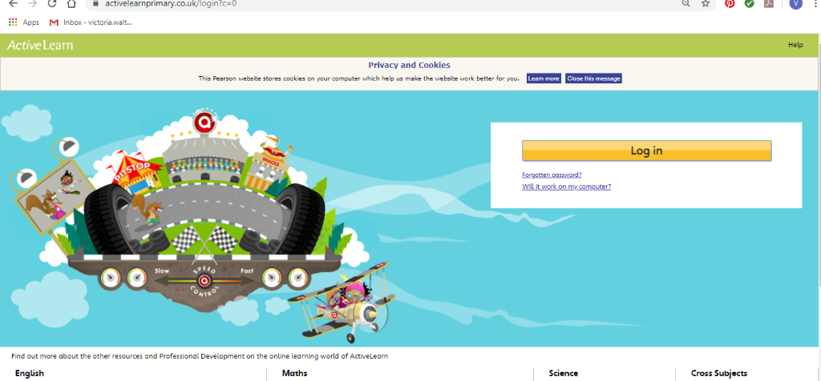Maths – You will need to Log in to Active Learn to access the maths learning. Google Active Learn Primary then you can Log in to access your account. Your username and password were included in the Home Learning booklet sent out when school finished. If you are unable to find this, plea se let me know.

Once you are logged in, select the ‘My stuff’ tab and click on the abacus icon to find the maths work I have sent to you.
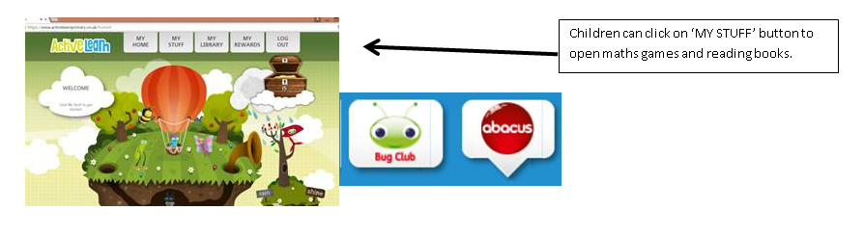
You will find maths games, activities and sometimes videos. For the main maths focus there are 4 different levels – support/core/extend/challenge. Please choose the appropriate level and challenge yourself to move to the next level the following day. For the interactive games you need to move through the levels – Bronze, Silver and gold. Once completed a level it will then unlock the next one. Sometimes there will be worksheets to complete. These can be printed, or you could have it up on screen and record on paper.
After completing your activities, you will win tokens which you can spend in the games zones.
Literacy Reading– Again you will need to access the reading books I send you through Active learn. This time go to the ‘My stuff’ tab and select the ‘Bug Club’ icon. You will see a list of books that I would like you to read. To open a book just click and it will open on your computer screen. Throughout the book are ‘bugs’ to click on and answer some questions to earn points. When the bug is answered return to the book to complete it. At the end of the book you will be able to see if all bugs have been answered and then asked to add a smiley face depending on whether you enjoyed it or not.
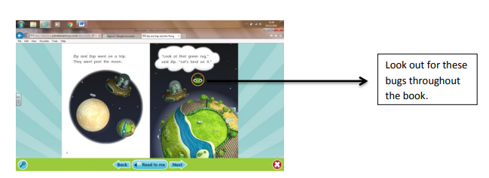

Literacy Grammar & Spelling This time click the Grammar & Spelling bug.
In this tab there may be a video to watch to explain a spelling rule and then games to play that are based on grammar or spelling strategies.

Parents - You can click the link to see a short video on the programmes available in JiT here https://www.j2e.com/help/videos/JIT

