Reception Home Learning
Week Beginning: 20.4.20
Reception
Daily Do’s - 10 minutes each
- Counting & Remembered Facts: 1 more and 1 less to 10, number bonds to 5 (then 10 when confident), counting to 20 forwards and backwards, counting in 2’s to 20, counting in 10’s to 100.
- Tricky words – See shared file on Hwb. Please work on your current level and when ready progress to the next.
- Cymraeg - please scan the QR code below

Monday | - Maths: Number formation 0 to 5.( See powerpoint in hwb file)  Multisensory activity - use felt pens/crayons/ make out of playdough/ form in glitter etc  - Literacy Reading: Bug club story and click the ‘bugs’ to answer questions  - Investigation: Grow your own rainbow https://www.thebestideasforkids.com/grow-a-rainbow-experiment/
Tuesday | - Maths: Number formation 6 to 10 ( See powerpoint in hwb file)  Multisensory activity - use felt pens/crayons/ make out of playdough/ form in glitter etc  - Literacy Reading: Bug club story and click the ‘bugs’ to answer questions  - : Health & Well-Being: medicines and harmful substances ( See powerpoint in hwb file)
Wednesday | - Maths: counting in 10’s (ACTIVE LEARN) – my stuff)  - Literacy: Spelling - use the sounds cards to make as many words as you can. You can have a go at writing them too (see sound cards in hwb file)  - Creative: Choose 1 rainbow craft to make. Here are some ideas - https://www.easypeasyandfun.com/rainbow-crafts-for-kids/
Thursday | - Maths:Number bonds (ACTIVE LEARN) - see my stuff)  - Literacy Writing: Simple sentences (The birthday party scene)– look at the picture and write about the birthday party. Remember to FRED talk each word. (see Hwb – My files)  - Active: PE with Joe Wicks https://www.youtube.com/user/thebodycoach1
Friday | - Maths: Play mushroom mayhem (ACTIVE LEARN) - see my stuff)  - Literacy Writing: Simple sentences (The swimming pool scene)– look at the picture and write about the swimming pool. (see Hwb – My files)  - Outdoor Learning: Spring Scavenger Hunt - see Hwb – my Files)  - DCF: Use JiT Write in Hwb. Choose a spring background and write sentences about what you did over Easter Can you change the font colour, style and size of your writing?

Reception Home Learning
Instructions
Daily Do’s – Counting & Remembered facts Each day spend 5-10 minutes on these counting targets.
Cymraeg Scan the QR code which will lead you to Quizlet where you can
practice and play games based on these Welsh patterns.

Tricky Words Spend some time each day to go over the words you are learning at the
Moment. Please move on when you are confident and can read the words out of
order too. I have included a PowerPoint for you to use if you wish. You can also play different games such as snap/matching pairs/hunt the word

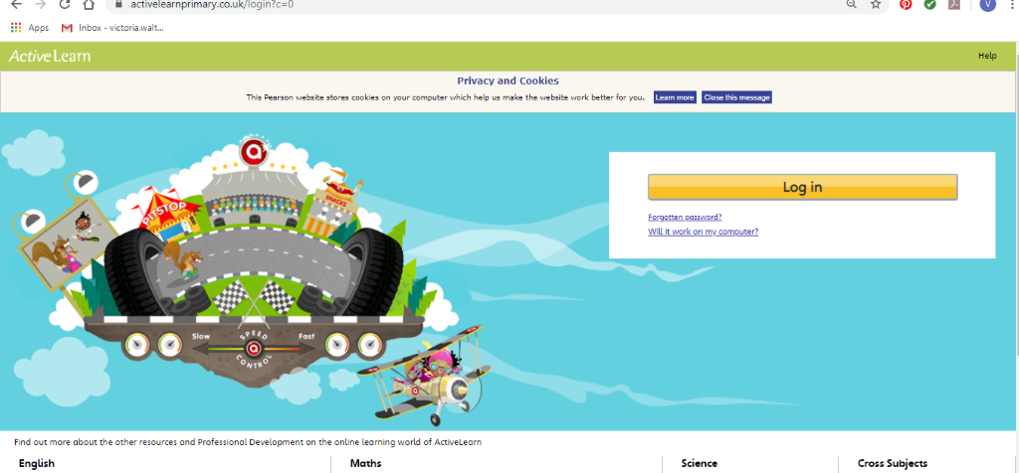Maths – You will need to Log in to Active Learn to access the maths learning. Google Active Learn Primary then you can Log in to access your account. Your username and password were included in the Home Learning booklet sent out when school finished. If you are unable to find this, plea se let me know.

Once you are logged in, select the ‘My stuff’ tab and click on the abacus icon to find the maths work I have sent to you.
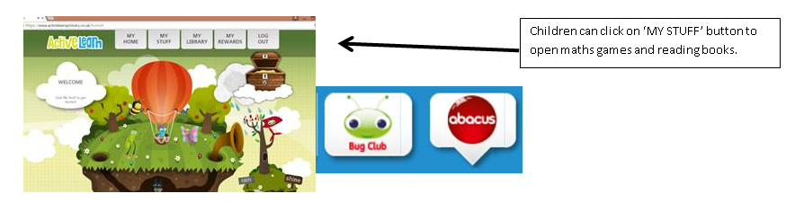
You will find maths games, activities and sometimes videos. For the main maths focus there are 4 different levels – support/core/extend/challenge. Please choose the appropriate level and challenge yourself to move to the next level the following day. For the interactive games you need to move through the levels – Bronze, Silver and gold. Once completed a level it will then unlock the next one. Sometimes there will be worksheets to complete. These can be printed, or you could have it up on screen and record on paper.
After completing your activities, you will win tokens which you can spend in the games zones.

Literacy Reading– Again you will need to access the reading books I send you through Active learn. This time go to the ‘My stuff’ tab and select the ‘Bug Club’ icon. You will see a list of books that I would like you to read. To open a book just click and it will open on your computer screen. Throughout the book are ‘bugs’ to click on and answer some questions to earn points. When the bug is answered return to the book to complete it. At the end of the book you will be able to see if all bugs have been answered and then asked to add a smiley face depending on whether you enjoyed it or not.
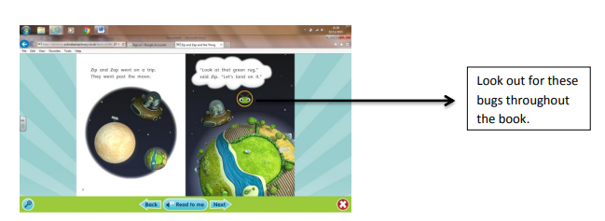

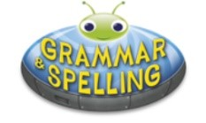
Literacy Grammar & Spelling This time click the Grammar & Spelling bug.
In this tab there may be a video to watch to explain a spelling rule and then games to play that are based on grammar or spelling strategies.
Literacy Writing – I would like you to do some sentence writing this week. I have shared two pictures with you called ‘At the swimming pool’ and ‘The birthday party’’. Remember to FRED talk (sound out) each sentence that you write. You can either write in your book, print out the sheets or write your story using ‘write’ in JiT. Remember to save it in your ‘home learning’ file if you do so that I can read it. You could also ask an adult to take a photo of your work and you can email it to me. I am looking forward to reading your sentences.

Investigation- Please have a go of growing your own rainbow. I hope you enjoy watching what happens and try to explain what you see to your parents. Maybe you could have a go at recording what you did and what you saw. This can be done in many ways e.g. taking a photograph and sharing it with us on Twitter, drawing/writing about what you did, what equipment you needed and what you found out.
Health & Well-Being – This week in school we would have been learning about keeping safe around medicines and harmful substances. I have included a PowerPoint to go through and an activity sheet. If you do not have access to a printer then maybe they could draw/write on paper instead.
Creative – Follow the link and have some fun together creating a rainbow craft. I would love to see your creations, maybe you could send me a photo on Twitter or email me a picture.
Active- Joe Wicks (the body coach) is live on his You Tube channel each morning at 9am. Join in with a workout. I will be taking part too! Don’t worry if the time is not suitable for you as you can watch and complete later in the day.
Outdoor Learning – Go on a Spring scavenger hunt in your garden. I have provided a sheet to complete, see if you can find everything on my list! If the weather is not too good on this day then please complete when possible.
DCF – I would love to find out about your Easter celebrations and activities. You can Log into Hwb and go to JiT.

Select ‘Write’ and type some sentences. Remember to name and save your work so I can look at it.

Parents - You can click the link to see a short video on the programmes available in JiT here https://www.j2e.com/help/videos/JIT

