Reception Home Learning
Week Beginning: 27.4.20
Reception
Daily Do’s - 10 minutes each
- Counting & Remembered Facts: doubles and halves to 10, count on in 1’s to 20, count back from 20.
- Tricky words – See shared file on Hwb. Please work on your current level and when ready progress to the next.
- Cymraeg - please scan the QR code below

Monday | - Maths: addition using a number line (see Hwb folder). You will find a number line in your Hwb folder.  - Literacy Reading: Bug club story and click the ‘bugs’ to answer questions (Active Learn – My stuff)  - Science: stages of human growth (See powerpoint and activity sheet in hwb folder)
Tuesday | - Maths: Subtraction using a number line (see Hwb folder). You will find a number line in your Hwb folder.  - Literacy Reading: Bug club story and click the ‘bugs’ to answer questions (Active learn – My stuff)  - Health & Well-Being: Groups I belong to - PPT & design shield activity (See Hwb files)
Wednesday | - Maths: Addition and subtraction word problems (see Hwb folder)  - Literacy: Spelling and grammar bug: Making sentences (Active learn – My stuff)  - Outdoor Learning: Spring Flower Hunt - PPT and checklist (See Hwb files)  - DCF: use JIT5 on Hwb to paint the spring flowers that you found on your outdoor learning walk.
Thursday | - Maths: Continue addition and subtraction word problems (see hwb folder)  - Literacy Writing: Sentence unscramble powerpoint and activity sheet.(Choose 3) (see Hwb – My files)  - Active: Exercise challenge – Spell out your name and do each exercise (See hwb folder) For an extra challenge – try your surname too!
Friday | - Maths: Rainy Daze adding and subtraction game (ACTIVE LEARN) - see my stuff)  - Literacy Writing: Continue sentence unscramble (choose 3) (see Hwb – My files)  - Cooking: Funny Faces cooking activity (see hwb folder)

Reception Home Learning
Instructions
Daily Do’s – Counting & Remembered facts Each day spend 5-10 minutes on these counting targets.
Cymraeg Scan the QR code which will lead you to Quizlet where you can
practice and play games based on these Welsh patterns.

Tricky Words Spend some time each day to go over the words you are learning at the
Moment. Please move on when you are confident and can read the words out of
order too. I have included a PowerPoint for you to use if you wish. You can also play different games such as snap/matching pairs/hunt the word

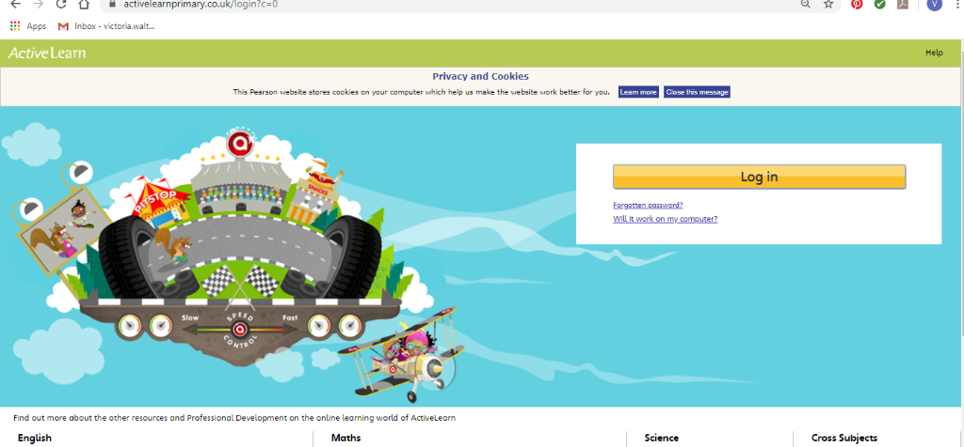Maths – You will need to Log in to Active Learn to access the maths learning. Google Active Learn Primary then you can Log in to access your account. Your username and password were included in the Home Learning booklet sent out when school finished. If you are unable to find this, plea se let me know.

Once you are logged in, select the ‘My stuff’ tab and click on the abacus icon to find the maths work I have sent to you.
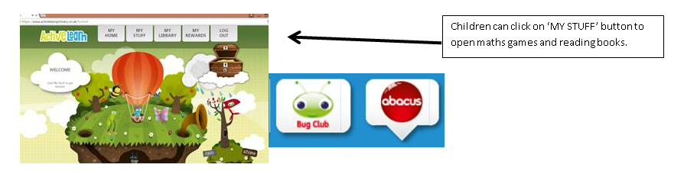
You will find maths games, activities and sometimes videos. For the main maths focus there are 4 different levels – support/core/extend/challenge. Please choose the appropriate level and challenge yourself to move to the next level the following day. For the interactive games you need to move through the levels – Bronze, Silver and gold. Once completed a level it will then unlock the next one. Sometimes there will be worksheets to complete. These can be printed, or you could have it up on screen and record on paper.
After completing your activities, you will win tokens which you can spend in the games zones.

Literacy Reading– Again you will need to access the reading books I send you through Active learn. This time go to the ‘My stuff’ tab and select the ‘Bug Club’ icon. You will see a list of books that I would like you to read. To open a book just click and it will open on your computer screen. Throughout the book are ‘bugs’ to click on and answer some questions to earn points. When the bug is answered return to the book to complete it. At the end of the book you will be able to see if all bugs have been answered and then asked to add a smiley face depending on whether you enjoyed it or not.
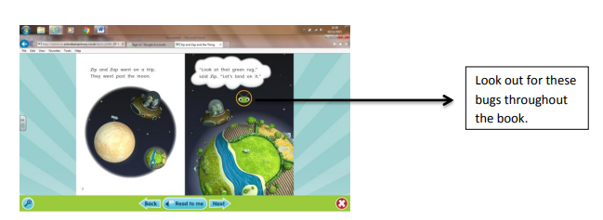

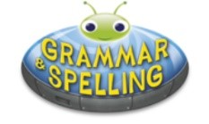
Literacy Grammar & Spelling This time click the Grammar & Spelling bug.
In this tab there may be a video to watch to explain a spelling rule and then games to play that are based on grammar or spelling strategies.
Literacy Writing – I would like you to look at the sentence unscramble powerpoint that I have shared with you on Hwb. I have given you a pack of 10 sentences. The words have been jumbled up and are not in the correct order. I would like you to choose 3 sentences to unscramble on Thursday and an additional 3 sentences for Friday. If you have access to a printer you can print out these sheets or alternatively you can type them up in j2e write.
Health & Well-Being – I bet we are all missing our friends at the moment and going to the different clubs and groups we are a part of, I know I am. I would like to find out about the different groups you belong to. This can be inside and outside of school. I have included a PowerPoint to look at and discuss and an activity sheet for you to design your own shield. If you do not have access to a printer then maybe they could draw/write on paper instead.
Science – this week we are learning about the stages of human growth from a newborn baby to being elderly. Please look at the powerpoint that I have shared with you on Hwb and then cut out the different stages and place them in the correct order.
Cooking – Funny Faces – you can be as creative as you like with this cooking activity! Make some funny faces using a variety of fruits, vegetables or foods that you find in your cupboard. We would love to see your creations so please take a photo and tweet it or email the photo to us!
Active- The name game is a fun fitness activity that you and your family can do together to have fun and get fit! First write out your name before doing the activity. Complete the activity listed for each letter. You could start with just jour first name and then challenge yourself to complete your full name. If you are looking for a real challenge, write your middle name or the names of each member of your family! I think it would be great fun to get other members of your family doing this too!
Outdoor Learning – This week I would like you to go on a Spring Flower hunt. Before you set off have a look at the Spring Flowers PowerPoint which I have saved in the shared folder on Hwb. Have you seen any of the flowers already? Can you name them? With an adult go on a Spring Flower hunt. This could be during a daily walk with your family or even in your garden. I have provided a sheet to complete. I wonder how many flowers you will find? If the weather is not too good on this day, then please complete when possible.
DCF – After you have been on your spring flower hunt, I would like you to Log into Hwb and go to JiT.

Select ‘Paint’ and use the tools to draw your favourite spring flower. Maybe you could type the name of it too. Remember to name and save your work in your ‘Home Learning’ file so I can look at it.

Parents - You can click the link to see a short video on the programmes available in JiT here https://www.j2e.com/help/videos/JIT

