Reception Home Learning
Week Beginning: 4.5.20
Reception
Daily Do’s - 10 minutes each
- Counting & Remembered Facts: doubles and halves to 10, count on in 1’s to 20, count back from 20. Count in 2’s to 20, count in 10’s to 100
- Tricky words – See shared file on Hwb. Please work on your current level and when ready progress to the next.
- Cymraeg - please scan the QR code below

Monday | - Maths: Days of the week song. Sequence days of the week activity (see Hwb folder).  - Literacy Reading: Bug club story and click the ‘bugs’ to answer questions (Active Learn – My stuff)  - Science: Experiment – Hand washing (See Hwb folder)
Tuesday | - Maths: Months of the year powerpoint and sequencing activity (see Hwb folder).  - Literacy Reading: Bug club story and click the ‘bugs’ to answer questions (Active learn – My stuff)  - Health & Well-Being: My happiness tree (See Hwb files)
Wednesday | - Maths: o’ clock powerpoint . Make a clock face (see Hwb folder)  - Literacy: Spelling and grammar bug: Capital letters. (Active learn – My stuff)  - DCF: Physical coding (See Hwb files)
Thursday | - Maths: o’ clock bingo (see hwb folder)  - Literacy Writing: Rhyming words powerpoint (See Hwb files) Listen to the story ‘The Rhyming Rabbit’ . Click on the following link www.youtube.com/watch?v=K_N0L9rtSIY . Complete rhyming string activity (See Hwb files)  - Active: Cosmic Yoga www.youtube.com/watch?v=U9Q6FKF12Qs  - Outdoor learning/ Creative :Natural art activity (see hwb folder)
Friday | PARTY TIME!!! VE day celebrations. Please see Hwb folder for ideas and activities to hold your own VE day celebration party at home. We would love to see photographs of your celebrations so please email them to us, put them in your Hwb folder or put pictures on Twitter with the tag @pennardprimary.

Reception Home Learning
Instructions
Daily Do’s – Counting & Remembered facts Each day spend 5-10 minutes on these counting targets.
Cymraeg Scan the QR code which will lead you to Quizlet where you can
practice and play games based on these Welsh patterns.

Tricky Words Spend some time each day to go over the words you are learning at the
Moment. Please move on when you are confident and can read the words out of
order too. I have included a PowerPoint for you to use if you wish. You can also play different games such as snap/matching pairs/hunt the word

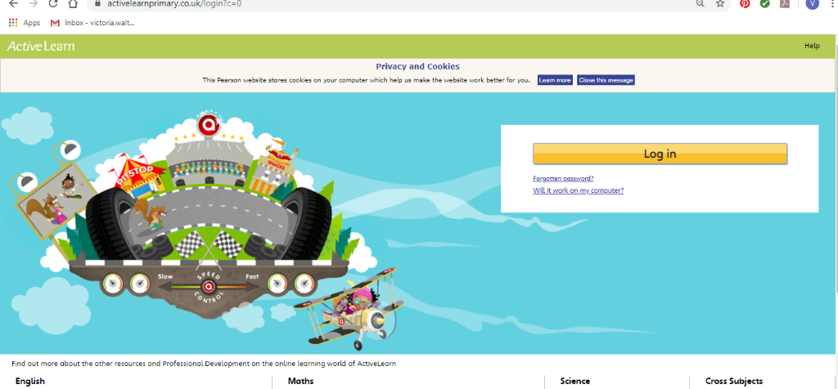Maths – You will need to Log in to Active Learn to access the maths learning. Google Active Learn Primary then you can Log in to access your account. Your username and password were included in the Home Learning booklet sent out when school finished. If you are unable to find this, plea se let me know.

Once you are logged in, select the ‘My stuff’ tab and click on the abacus icon to find the maths work I have sent to you.
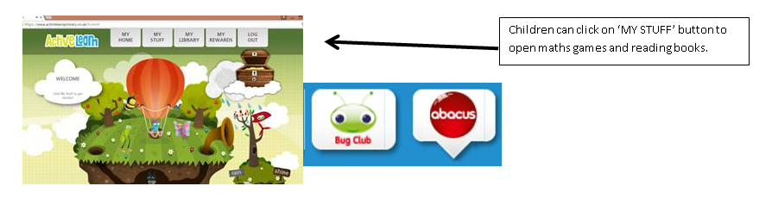
You will find maths games, activities and sometimes videos. For the main maths focus there are 4 different levels – support/core/extend/challenge. Please choose the appropriate level and challenge yourself to move to the next level the following day. For the interactive games you need to move through the levels – Bronze, Silver and gold. Once completed a level it will then unlock the next one. Sometimes there will be worksheets to complete. These can be printed, or you could have it up on screen and record on paper.
After completing your activities, you will win tokens which you can spend in the games zones.
Maths – The theme for this week is ‘Time’. All of the activities I have allocated to you in your Hwb folder. You will find these activities by logging into Hwb, select Just2easy, my files. On the left hand side of the screen select shared files, click on your name and the reources for this week should be in a folder named Reception home learning 4.5.20.

Literacy Reading– Again you will need to access the reading books I send you through Active learn. This time go to the ‘My stuff’ tab and select the ‘Bug Club’ icon. You will see a list of books that I would like you to read. To open a book just click and it will open on your computer screen. Throughout the book are ‘bugs’ to click on and answer some questions to earn points. When the bug is answered return to the book to complete it. At the end of the book you will be able to see if all bugs have been answered and then asked to add a smiley face depending on whether you enjoyed it or not.
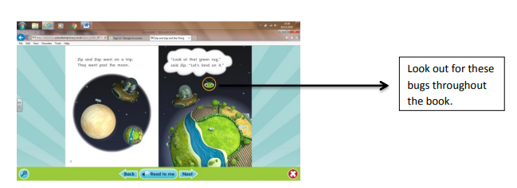

Literacy Grammar & Spelling This time click the Grammar & Spelling bug.
In this tab there may be a video to watch to explain a spelling rule and then games to play that are based on grammar or spelling strategies.
Literacy Writing – This week we are learning about rhyming strings e.g bat, cat, hat. Please look at the powerpoint I have shared with you. I have included a link for a wonderful rhyming story by Julia Donaldson called ‘The Rhyming Rabbit. www.youtube.com/watch?v=K_N0L9rtSIY.
Please listen to the story and complete the rhyming activities that I have given you.

Health & Well-Being – There are some days when we all need reminding about all the things that make us happy. Myself and Mrs Eynon thought about what makes us happy – have a look, we made our own happiness tree. Can you make one to show all the things that make you happy?
Science – We have been talking a lot about the importance of washing our hands properly and we have talked about how germs can spread. In your hwb folder I have included a set of instruction on how to carry out this interesting investigation!
Active- Cosmic yoga. We have really enjoyed Cosmic Yoga during our PE lessons in school. Here is a really fun Yoga session based on the film ‘Trolls’ www.youtube.com/watch?v=U9Q6FKF12Qs
Outdoor Learning/ Art - This week we are combining our creative and outdoor learning lesson. Look around your garden to find some natural objects such as pebbles, twigs, leaves, flowers. Be creative and make an outdoor piece of artwork. I have shared some ideas with you on Hwb.
DCF – Physical coding. This activity is all about giving instructions to move from one place to another. You can use your toys to help you! You will find the instructions on how to make a grid in your hwb folder or if you would prefer you can print out the coding mat that I have included for you.

Parents - You can click the link to see a short video on the programmes available in JiT here https://www.j2e.com/help/videos/JIT

