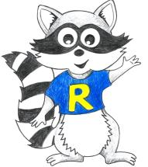
Year 1 Home Learning
Week Beginning: 1.6.20
Year 1
Daily Do’s
Counting & Remembered Facts: Count on in 2’s to 100
- Cymraeg: Scan the QR code for this week’s Welsh games. Also look at Pennard Primary’s Twitter page for more
Welsh games.
- Tricky words (Practice reading your level words-if applicable) PPT in (Hwb files - see resourc es section below)
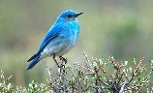
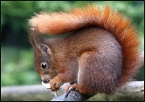
National Wildlife Week 2020
Monday | Maths  Making amounts– Choose a level (support/core/extend/challenge) |  | Literacy  Bug club story 1 and click the ‘bugs’ to answer questions |  |  | Science  Look at British bird PowerPoint. Then go on RSPB website and select - Which bird song is that? https://www.rspb.org.uk/birds-and-wildlife/bird-songs/what-bird-is-that/ Complete ‘Which bird song is that?’ activity (Hwb files - see resources section below)
 | Tric a Chlic: Cam 1 - Pinc Sain ‘j’ https://www.youtube.com/watch?v=uYxSuH9Yzyk&t=24s
Tuesday | Maths  Making amounts– Choose a level (support/core/extend/challenge) Move on from yesterday! |  | Literacy  Bug club story 2 and click the ‘bugs’ to answer questions |  |  | Literacy  Birds in your garden reading comprehension– (Hwb files - see resources section)
 | Tric a Chlic: Cam 1 - Pinc Sain ‘f’ https://www.youtube.com/watch?v=8DWbZNWgz5I
Wednesday | Maths  Marching Madness game– can you get to GOLD! |  | Abacus Grammar & Spelling Bug  Sentence Punctuation– Watch video and play 2 games |  |  | Outdoor learning  Bird counting tally (Hwb files - see resources section)
 | Tric a Chlic: Cam 1 - Pinc Sain ‘dd’ https://www.youtube.com/watch?v=0EesvOosdvQ
Thursday | Maths  Problem Solving – Treasure Hunt & Pairs in purses | Literacy  British wildlife writing – Squirrel or hedgehog factsheet (Hwb files - see resources section below) |  |  |  | Health and well-being  Listen to birdsong radio https://www.rspb.org.uk/get-involved/campaigning/let-nature-sing/birdsong-radio/ and complete a mindfulness colouring in of your choice. (Hwb files - see resources section below
 | Tric a Chlic: Cam 1 - Pinc Sain ‘ff’ https://www.youtube.com/watch?v=9hOeOEmXUeE
Friday | Maths  challenge yourself with the Mastery challenge on Abacus – finding amounts made up of several coins |  |  | Spelling  Spellblast in J2blast – Choose a spelling list to practice | Active  Cosmic yoga – Tallulah the owlet - https://www.youtube.com/watch?v=2aje33UPixE  Creative  Make a bird feeder craft (Hwb files - see resources section below) and see https://www.bbc.co.uk/cbeebies/makes/bird-feeder
 | Tric a Chlic: Cam 1 –Pinc Sain ‘rh’ https://www.youtube.com/watch?v=Kdn07sRt_FM
Resources | Maths - https://www.activelearnprimary.co.uk/start  Literacy Reading, Grammar & Spelling - https://www.activelearnprimary.co.uk/start  Active - https://www.youtube.com/watch?v=2aje33UPixE  Tricky Words, Science, Reading, Outdoor learning, writing, Health & Well-being, creative– Follow the pathway below.  Hwb J2e my files shared files Year 1 Home Learning week 1

Year 1 Home Learning
Instructions
Daily Do’s – Counting & Remembered facts Each day spend 5-10 minutes on these counting targets.
Please use the 100 square I have shared with you in the folder if you need it. I have also shared the PowerPoint we
sometimes use in class to help if you find it useful.
Cymraeg Scan the QR code which will lead you to Quizlet where you can
practice and play games based on these Welsh patterns.

Tricky Words Spend some time each day to go over the words you are learning at the
Moment. Please move on when you are confident and can read the words out of
order too. I have included a PowerPoint for you to use if you wish. You can also play different games such as
snap/matching pairs/hunt the word
Tric a Chlic – To help you carry on learning the Welsh sounds we have been learning in our Tric a Chlic sessions in school, I have added a link to short video podcasts. Please enjoy revising the sounds.
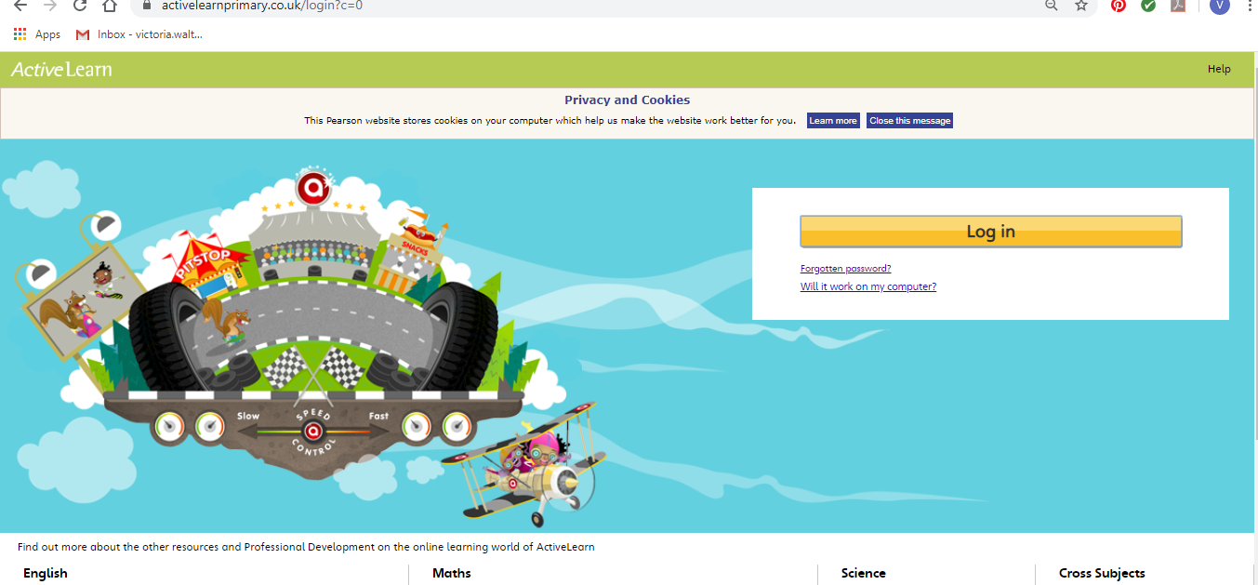
Maths – You will need to Log in to Active Learn to access the maths learning. Google Active Learn Primary then you can Log in to access your account. Your username and password were included in the Home Learning booklet sent out when school finished. If you are unable to find this, plea se let me know.

Once you are logged in, select the ‘My stuff’ tab and click on the abacus icon to find the maths work I have sent to you.
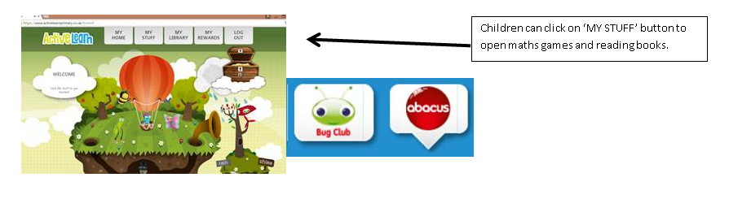

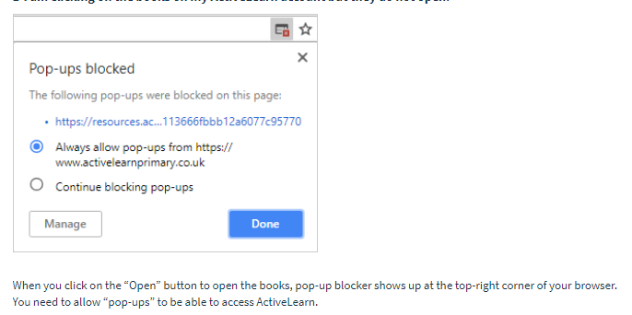
You will find maths games, activities and sometimes videos. For the main maths focus there are 4 different levels – support/core/extend/challenge. Please choose the appropriate level and challenge yourself to move to the next level the following day. For the interactive games you need to move through the levels – Bronze, Silver and gold. Once completed a level it will then unlock the next one. Sometimes there will be worksheets to complete. These can be printed, or you could have it up on screen and record on paper.
After completing your activities, you will win tokens which you can spend in the games zones.
If you have trouble launching the activities, check your pop up blocker is switched off

Literacy Reading– Again you will need to access the reading books I send you through Active learn. This time go to the ‘My stuff’ tab and select the ‘Bug Club’ icon. You will see a list of books that I would like you to read. To open a book just click and it will open on your computer screen. Throughout the book are ‘bugs’ to click on and answer some questions to earn points. When the bug is answered return to the book to complete it. At the end of the book you will be able to see if all bugs have been answered and then asked to add a smiley face depending on whether you enjoyed it or not.
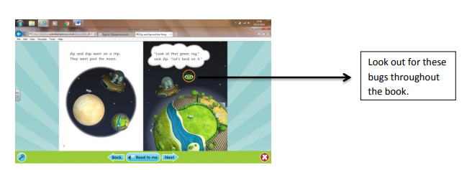

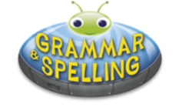
Literacy Grammar & Spelling This time click the Grammar & Spelling bug.
In this tab there may be a video to watch to explain a spelling rule and then games to play that are based on grammar or spelling strategies.

Science - Which birdsong is that? Every morning I love waking up to the sounds of the birds singing. I always wonder what they look like! Have a look at the British Birds PowerPoint I have shared with you then click on the link above (Monday) to hear the sounds each bird makes. Print out the which birdsong is it activity sheet and spend a little time during your daily walk listening out for each of the birds singing. You could record them on a phone or iPad if you want to.

Literacy Reading: I have shared Birds in your garden reading comprehensions with you. There are 3 different levels *, **, ***. Please read the one that you are comfortable with and answer the questions.

Outdoor Learning: Bird counting tally. Go out into your garden or take on your daily walk. Have a good look to see how many of each type of bird you can find. Then have a go of recording your results in a graph and answering the questions.

Literacy Writing – To develop your knowledge about some garden wildlife I have included PowerPoints about squirrels and hedgehogs. Choose one to read (or both if you wish!) I would then like you make a fact sheet about your chosen animal. I have shared a template with you but record in any way you prefer. You may like to get creative a draw/collage your animal and write facts around it.

Health & Well-Being – We all need some time now and again to completely relax and take our minds off any worries we might have. This activity will help you to relax your body and your mind. Click on the link for the RSPB birdsong radio. Listen to the relaxing sounds and choose a mindfulness colouring in sheet to complete. Remember to be neat and stay inside the lines!

Active – We all love owls! Especially baby owls – Have a go at Tallulah the owlet Cosmic Yoga activity. Click on the link above to take you to it

Creative – Make a bird feeder craft. Follow the instructions that I have given you to make a bird feeder. There are also some great ones on the CBeebies website (link above) that you can look at. You can put it out your garden to encourage more beautiful birds into your garden.

Spelling:
- Log into Hwb
- Click Just2easy
- Click on the J2blast tile
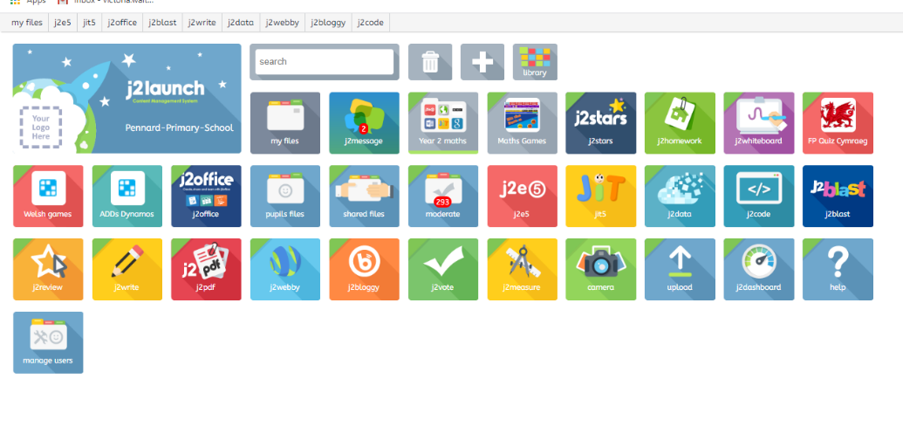
- Select Spell blast

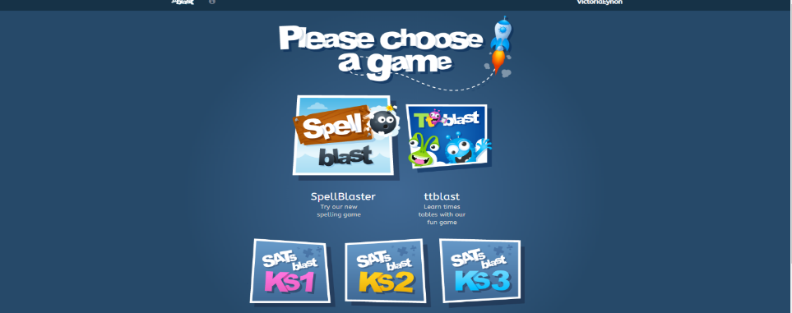

- Select Have a practice and you can choose year group spelling lists using the slider.
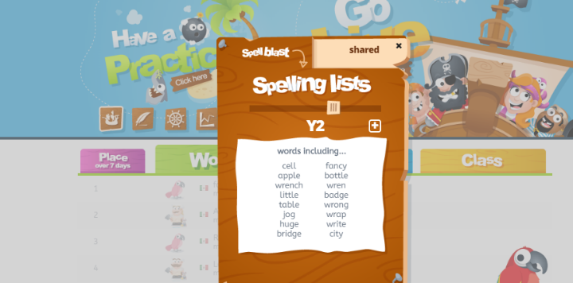

- If you select the shared tab on the right you will see the different colour HFW spelling lists we use in school. You will be able to select the colour your child is learning at the moment for them to practice. I have recorded myself saying each word! Click on the arrows at the bottom to see all lists.

