Year 1 Home Learning
Week Beginning: 20.4.20
Year 1
Daily Do’s
- Counting & Remembered Facts: All pairs of numbers with total of 10, Count on in 1’s to 100 and from different starting points
- Cymraeg: Scan the QR code for this week’s Welsh games. Also look at Pennard Primary’s Twitter page for more
- Welsh games.
- Tricky words (Practice reading your level words-if applicable) PPT in (Hwb files - see resources section below)
Monday | - Maths: Ordering numbers – Choose a level (support/core/extend/challenge)  - Literacy Reading: Bug club story 1 and click the ‘bugs’ to answer questions  - Investigation: Grow your own rainbow https://www.thebestideasforkids.com/grow-a-rainbow-experiment/  - Tric a Chlic: Cam 1 Melyn Sain ‘m’ https://www.youtube.com/watch?v=VBoQgs3rsNw
Tuesday | - Maths: Ordering numbers – Choose a level (support/core/extend/challenge) Move on from yesterday!  - Literacy Reading: : Bug club story 2 and click the ‘bugs’ to answer questions  - Health & Well-Being: medicines and harmful substances - PPT & Medicine or not activity (Hwb files - see resources section below)  - Tric a Chlic: Cam 1 Melyn Sain ‘a’ https://www.youtube.com/watch?v=TEnthSCF7nA
Wednesday | - Maths: Hedgehog Hurry game – can you get to GOLD!  - Literacy Spelling: Grammar & Spelling Bug Spelling: The Alphabet – Watch video and play 2 games  - Creative: Choose 1 rainbow craft to make. Here are some ideas - https://www.easypeasyandfun.com/rainbow-crafts-for-kids/  - Tric a Chlic: Cam 1 Melyn Sain ‘p’ https://www.youtube.com/watch?v=OXl9EnVzI8A
Thursday | - Maths: Problem Solving – Domino digits  - Literacy Writing: We were at the zoo…. – look at the picture, read the story starter, use your imagination and finish the story. (Hwb files - see resources section below)  - Active: PE with Joe Wicks https://www.youtube.com/user/thebodycoach1  - Tric a Chlic: Cam 1 Melyn Sain ‘h’ https://www.youtube.com/watch?v=WI2bThVZF1c
Friday | - Maths: Number Formation to 20 (see rhyme cards and tracing strips in Hwb folder) & challenge yourself with the Mastery challenge on Abacus – placing 2-digit numbers on a line  - Outdoor Learning: Spring Scavenger Hunt (Hwb files - see resources section below)  - DCF: Use JiT ‘Write’ in Hwb. Write sentences about what you did over Easter Can you change the font colour, style and size of your writing?  - Tric a Chlic: Cam 1 Melyn Sain ‘t’ https://www.youtube.com/watch?v=t5BzBQRHRgA
Resources | Maths - https://www.activelearnprimary.co.uk/start  Literacy Reading, Grammar & Spelling - https://www.activelearnprimary.co.uk/start  Tricky Words, Maths Number formation, Health & Well-Being, Literacy writing, Outdoor learning – Follow the pathway below.  Hwb J2e my files shared files Year 1 Home Learning week 1

Year 1 Home Learning
Instructions
Daily Do’s – Counting & Remembered facts Each day spend 5-10 minutes on these counting targets.
Please use the 100 square I have shared with you in the folder if you need it. I have also shared the PowerPoint we
sometimes use in class to help if you find it useful.
Cymraeg Scan the QR code which will lead you to Quizlet where you can
practice and play games based on these Welsh patterns.

Tricky Words Spend some time each day to go over the words you are learning at the
Moment. Please move on when you are confident and can read the words out of
order too. I have included a PowerPoint for you to use if you wish. You can also play different games such as
snap/matching pairs/hunt the word
Tric a Chlic – To help you carry on learning the Welsh sounds we have been learning in our Tric a Chlic sessions in school, I have added a link to short video podcasts. Please enjoy revising the sounds.

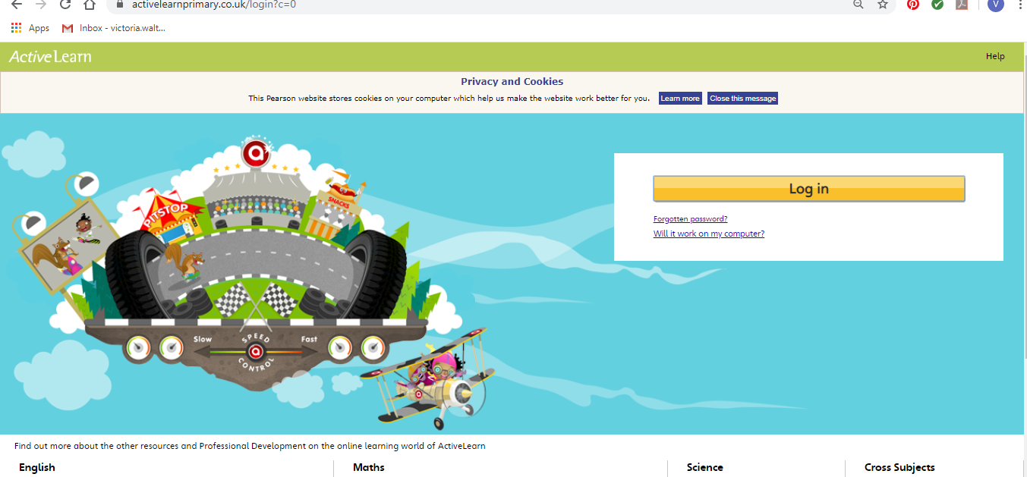
Maths – You will need to Log in to Active Learn to access the maths learning. Google Active Learn Primary then you can Log in to access your account. Your username and password were included in the Home Learning booklet sent out when school finished. If you are unable to find this, plea se let me know.

Once you are logged in, select the ‘My stuff’ tab and click on the abacus icon to find the maths work I have sent to you.

You will find maths games, activities and sometimes videos. For the main maths focus there are 4 different levels – support/core/extend/challenge. Please choose the appropriate level and challenge yourself to move to the next level the following day. For the interactive games you need to move through the levels – Bronze, Silver and gold. Once completed a level it will then unlock the next one. Sometimes there will be worksheets to complete. These can be printed, or you could have it up on screen and record on paper.
After completing your activities, you will win tokens which you can spend in the games zones.
If you have trouble launching the activities, check your pop up blocker is switched off

Literacy Reading– Again you will need to access the reading books I send you through Active learn. This time go to the ‘My stuff’ tab and select the ‘Bug Club’ icon. You will see a list of books that I would like you to read. To open a book just click and it will open on your computer screen. Throughout the book are ‘bugs’ to click on and answer some questions to earn points. When the bug is answered return to the book to complete it. At the end of the book you will be able to see if all bugs have been answered and then asked to add a smiley face depending on whether you enjoyed it or not.
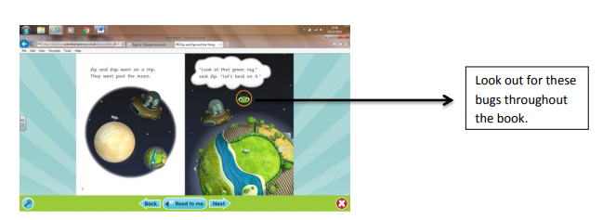

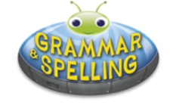
Literacy Grammar & Spelling This time click the Grammar & Spelling bug.
In this tab there may be a video to watch to explain a spelling rule and then games to play that are based on grammar or spelling strategies.
Literacy Writing – I would like you to do some creative writing this week. I have shared a story starter and picture with you called ‘At the zoo’. Can you read the story starter and then carry the story on? You can either write in your book, print out the sheets or write your story using ‘write’ in JiT. Remember to save it in your ‘home learning’ file if you do so that I can read it. You could also ask an adult to take a photo of your work and you can email it to me. I am looking forward to reading your stories.
I have put a marking grid in your folder to remind you what you need to include in your writing.
Investigation- Please have a go of growing your own rainbow. I hope you enjoy watching what happens and try to explain what you see to your parents. Maybe you could have a go at recording what you did and what you saw. This can be done in many ways e.g. taking a photograph and sharing it with us on Twitter, drawing/writing about what you did, what equipment you needed and what you found out.
Health & Well-Being – This week in school we would have been learning about keeping safe around medicines and harmful substances. I have included a PowerPoint to go through and an activity sheet. If you do not have access to a printer then maybe they could draw/write on paper instead.
Creative – Follow the link and have some fun together creating a rainbow craft. I would love to see your creations, maybe you could send me a photo on Twitter.
Active- Joe Wicks (the body coach) is live on his You Tube channel each morning at 9am. Join in with a workout. I will be taking part too! Don’t worry if the time is not suitable for you as you can watch and complete later in the day.
Outdoor Learning – Go on a Spring scavenger hunt in your garden. I have provided a sheet to complete, see if you can find everything on my list! If the weather is not too good on this day then please complete when possible.
DCF – I would love to find out about your Easter celebrations and activities. You can Log into Hwb and go to JiT.

Select ‘Write’ and type some sentences. Remember to name and save your work so I can look at it.

Parents - You can click the link to see a short video on the programmes available in JiT here https://www.j2e.com/help/videos/JIT

