Year 1 Home Learning
Week Beginning: 4.5.20
Year 1
Daily Do’s
- Counting & Remembered Facts: Addition facts for each number up to 10, Say a number that is one more than a
given number to 20
- Cymraeg: Scan the QR code for this week’s Welsh games. Also look at Pennard Primary’s Twitter page for more
Welsh games.
- Tricky words (Practice reading your level words-if applicable) PPT in (Hwb files - see resources section below)
Monday | - Maths: Sorting 2D shapes – Choose a level (support/core/extend/challenge)  - Literacy Reading: Bug club story 1 and click the ‘bugs’ to answer questions  - Science: How clean are your hands? Bread experiment - activity sheet (Hwb files - see resources section below)  - Tric a Chlic: Cam 1 - Glas Sain ‘th’ https://www.youtube.com/watch?v=DeaGiBV9_eM
Tuesday | - Maths: Sorting 2D shapes– Choose a level (support/core/extend/challenge) Move on from yesterday!  - Literacy Reading: : Bug club story 2 and click the ‘bugs’ to answer questions  - Health & Well-Being: Happiness Tree Have a look at Mrs Eynon’s and Mrs Thomas’ Happiness trees! (Hwb files - see resources section below)  - Tric a Chlic: Cam 1 - Glas Sain ‘n’ https://www.youtube.com/watch?v=1zk_VhwCmiQ
Wednesday | - Maths: Reel it in game – can you get to GOLD!  - Literacy Grammar: Grammar & Spelling Bug: Words & Sentences – Watch video and play 2 games  - DCF: Use ‘Turtle’ in JiT – Move the rocket to get to visit the different planets  - Tric a Chlic: Cam 1 - Glas Sain ‘b’ https://www.youtube.com/watch?v=KycRIVXVd_I
Thursday | - Maths: Problem Solving – Flip and Flop & challenge yourself with the Mastery challenge on Abacus – 2D shapes  - Literacy Writing: I woke up and looked out of the window…. – look at the picture, read the story starter, use your imagination and finish the story. (Hwb files - see resources section below)  - Active: Cosmic Yoga- Trolls www.youtube.com/watch?v=U9Q6FKF12Qs  - Tric a Chlic: Cam 1 - Glas Sain ‘g’ https://www.youtube.com/watch?v=WzKEeykmsJE
Friday | - VE Day –Information PowerPoint and reading comprehension (Hwb files - see resources section below)  - VE Day Celebrations - (Hwb files - see resources section below)
Resources | Maths - https://www.activelearnprimary.co.uk/start  Literacy Reading, Grammar & Spelling - https://www.activelearnprimary.co.uk/start  Active - www.youtube.com/watch?v=U9Q6FKF12Qs  Tricky Words, Maths Number formation, Health & Well-Being, Literacy writing, Science, VE Day – Follow the pathway below.  Hwb J2e my files shared files Year 1 Home Learning week 1

Year 1 Home Learning
Instructions
Daily Do’s – Counting & Remembered facts Each day spend 5-10 minutes on these counting targets.
Please use the 100 square I have shared with you in the folder if you need it. I have also shared the PowerPoint we
sometimes use in class to help if you find it useful.
Cymraeg Scan the QR code which will lead you to Quizlet where you can
practice and play games based on these Welsh patterns.

Tricky Words Spend some time each day to go over the words you are learning at the
Moment. Please move on when you are confident and can read the words out of
order too. I have included a PowerPoint for you to use if you wish. You can also play different games such as
snap/matching pairs/hunt the word
Tric a Chlic – To help you carry on learning the Welsh sounds we have been learning in our Tric a Chlic sessions in school, I have added a link to short video podcasts. Please enjoy revising the sounds.

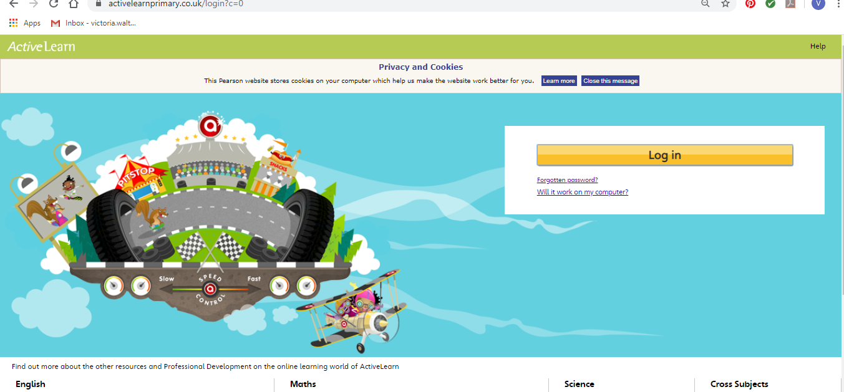
Maths – You will need to Log in to Active Learn to access the maths learning. Google Active Learn Primary then you can Log in to access your account. Your username and password were included in the Home Learning booklet sent out when school finished. If you are unable to find this, plea se let me know.

Once you are logged in, select the ‘My stuff’ tab and click on the abacus icon to find the maths work I have sent to you.
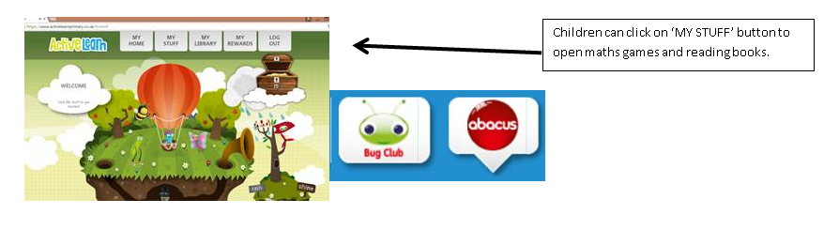

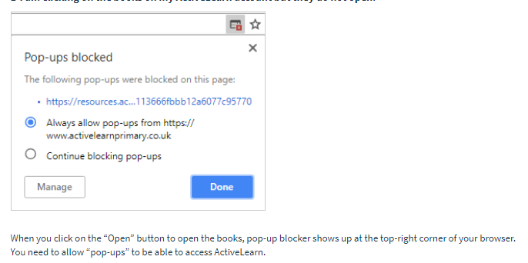
You will find maths games, activities and sometimes videos. For the main maths focus there are 4 different levels – support/core/extend/challenge. Please choose the appropriate level and challenge yourself to move to the next level the following day. For the interactive games you need to move through the levels – Bronze, Silver and gold. Once completed a level it will then unlock the next one. Sometimes there will be worksheets to complete. These can be printed, or you could have it up on screen and record on paper.
After completing your activities, you will win tokens which you can spend in the games zones.
If you have trouble launching the activities, check your pop up blocker is switched off

Literacy Reading– Again you will need to access the reading books I send you through Active learn. This time go to the ‘My stuff’ tab and select the ‘Bug Club’ icon. You will see a list of books that I would like you to read. To open a book just click and it will open on your computer screen. Throughout the book are ‘bugs’ to click on and answer some questions to earn points. When the bug is answered return to the book to complete it. At the end of the book you will be able to see if all bugs have been answered and then asked to add a smiley face depending on whether you enjoyed it or not.
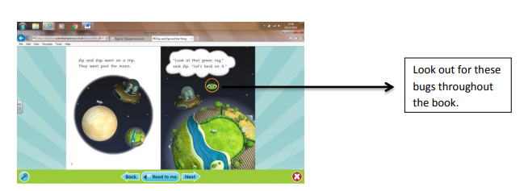

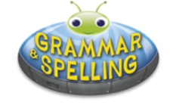
Literacy Grammar & Spelling This time click the Grammar & Spelling bug.
In this tab there may be a video to watch to explain a spelling rule and then games to play that are based on grammar or spelling strategies.
Literacy Writing – I would like you to do some creative writing this week. I have shared a story starter and picture with you called ‘We were walking through the woods ….’. Can you read the story starter and then carry the story on? You can either write in your book, print out the sheets or write your story using ‘write’ in JiT. Remember to save it in your ‘home learning’ file if you do so that I can read it. You could also ask an adult to take a photo of your work and upload it to your Hwb file. I am looking forward to reading your stories.
I have put a marking grid in your folder to remind you what you need to include in your writing.
Science – How clean are your hands? Follow the steps on the sheet I have shared with you in your folder. You can then write up your experiment like a scientist! I have shared a recording sheet with you in ‘shared files’ in Hwb. You can either print this out or record on your own paper.

Health & Well-Being – This week we are thinking about what makes you happy? I would like you to make a Happiness Tree. Give some thought to all the things you enjoy doing, and what makes you smile. Send me your ideas, I’d love to see them! #KeepSafe #KeepSmiling #BeHappy

Active – I am missing our Yoga sessions in school so here is a fun Yoga session based on the film ‘Trolls’. I am really looking forward to doing this at home too!

Outdoor Learning/Creative – This week we are combining our creative and outdoor learning lesson. Look around your garden to find some natural objects such as pebbles, twigs, leaves, flowers. Be creative and make an outdoor piece of artwork. I have shared some ideas with you on Hwb.
DCF – This week we are going to do some coding using the package ‘Turtle’. You need to Log into Hwb, select J2e
and go to JiT.

Next select ‘Turtle’

I would like you to select the space theme template. Using the arrows, have a go at making the rocket move to a planet. How can you get the rocket to the orange planet? Which direction will your rocket need to go to reach the red planet?
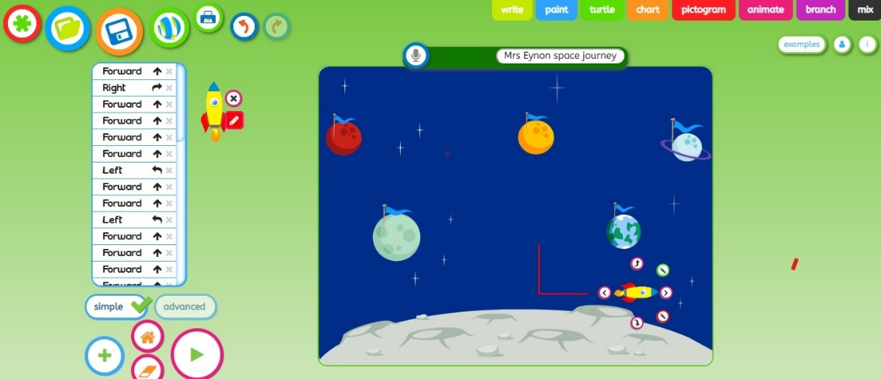
As your rocket (sprite) moves, look at the instructions that appear in the box on the left of the screen. This is an algorithm.
An algorithm is a set of instructions.

Press the play button to watch your rocket move in one go. Challenge: Can you make the rocket visit each planet in turn and return to base.
Remember to name and save your work in your ‘Home Learning’ file so I can look at it.
Parents - You can click the link below to see a short video on the Turtle’ programme

