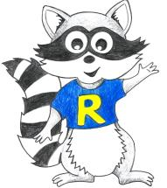
Year 2 Home Learning
Week Beginning: 11.5.20
Year 2
Daily Do’s
Counting & Remembered Facts: Halve even numbers to 20. Count on in 2’s from any given number
- Cymraeg: Scan the QR code for this week’s Welsh games. Also look at Pennard Primary’s Twitter page for more
Welsh games.
- Tricky words (Practice reading your level words-if applicable) PPT in (Hwb files - see resources section below)
Monday | - Maths: Addition Facts- Choose a level (support/core/extend/challenge)  - Literacy Reading: Bug club story 1 and click the ‘bugs’ to answer questions  - Topic: Time Capsule – Information sheet and booklet (Hwb files - see resources section below)  - Tric a Chlic: Cam 1 - Glas Sain ‘w’ https://www.youtube.com/watch?v=be7ECA-3CZw&t=66s
Tuesday | - Maths: Addition Facts- Choose a level (support/core/extend/challenge) Move on from yesterday!  - Literacy Reading: : Bug club story 2 and click the ‘bugs’ to answer questions  - Topic: Continue Time Capsule (Hwb files - see resources section below)  - Tric a Chlic: Cam 1 - Glas Sain ‘l’ https://www.youtube.com/watch?v=in6QGiKXIuc
Wednesday | - Maths: game –Toucan Team can you get to GOLD! & Homework sheet 2.13  - Literacy Grammar: Grammar & Spelling Bug: Noun Phrases- Watch video and play 2 games  - Science: Kitchen Science – Floating egg experiment (Hwb files - see resources section below)  - Tric a Chlic: Cam 1 - Glas Sain ‘o’ https://www.youtube.com/watch?v=56BIBhZtEto
Thursday | - Maths: Problem Solving –Star of Change  - Literacy Writing: Amazing Adjectives PowerPoint. Use picture to write sentences with amazing adjectives (Hwb files - see resources section below)  - Active: Garden obstacle course (Hwb files - see resources section below)  - Tric a Chlic: Cam 1 - Glas Sain ‘s’ https://www.youtube.com/watch?v=wOM78I99ZMY
Friday | - Maths: Mastery challenge on Abacus – Using place value & number facts to solve problems  - Outdoor Learning/Creative: Outdoor artwork (Hwb files - see resources section below)  - Tric a Chlic: Cam 1 - Glas Adolygu’r seiniau (revise all sounds) https://www.youtube.com/watch?v=719msN10jxQ
Resources | Maths - https://www.activelearnprimary.co.uk/start  Literacy Reading, Grammar & Spelling - https://www.activelearnprimary.co.uk/start  Tricky Words, Literacy writing, Science, Active, Time Capsule, Outdoor/creative – Follow the pathway below.  Hwb J2e my files shared files Year 2 Home Learning week 1

Year 2 Home Learning
Instructions
Daily Do’s – Counting & Remembered facts Each day spend 5-10 minutes on these counting targets.
I have also shared the PowerPoint we sometimes use in class to help if you find it useful.
Cymraeg Scan the QR code which will lead you to Quizlet where you can
practice and play games based on these Welsh patterns.

Tricky Words Spend some time each day to go over the words you are learning at the
Moment. Please move on when you are confident and can read the words out of
order too. I have included a PowerPoint for you to use if you wish. You can also play different games such as
snap/matching pairs/hunt the word

Tric a Chlic – To help you carry on learning the Welsh sounds we have been learning in our Tric a Chlic sessions in school, I have added a link to short video podcasts. Please enjoy revising the sounds.

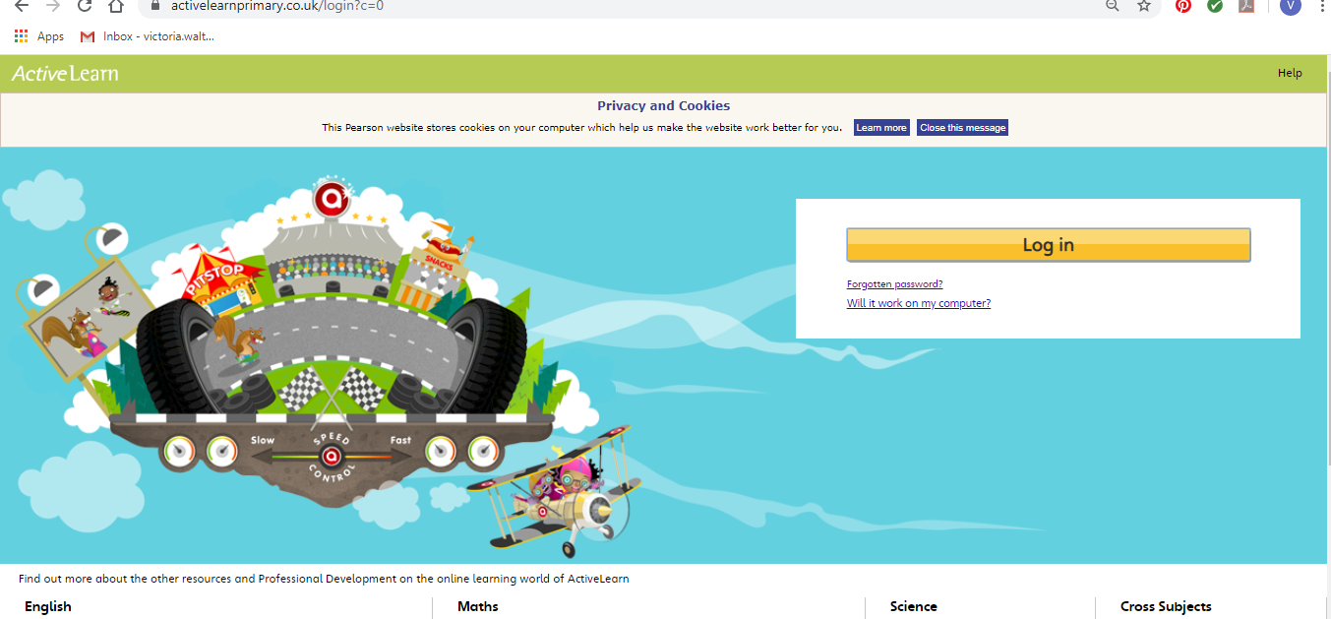
Maths – You will need to Log in to Active Learn to access the maths learning. Google Active Learn Primary then you can Log in to access your account. Your username and password were included in the Home Learning booklet sent out when school finished. If you are unable to find this, plea se let me know.

Once you are logged in, select the ‘My stuff’ tab and click on the abacus icon to find the maths work I have sent to you.
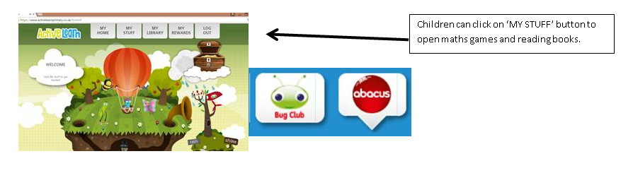

You will find maths games, activities and sometimes videos. For the main maths focus there are 4 different levels – support/core/extend/challenge. Please choose the appropriate level and challenge yourself to move to the next level the following day. For the interactive games you need to move through the levels – Bronze, Silver and gold. Once completed a level it will then unlock the next one. Sometimes there will be worksheets to complete. These can be printed, or you could have it up on screen and record on paper.
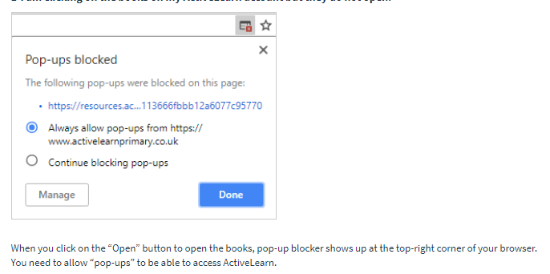
After completing your activities, you will win tokens which you can spend in the games zones.

If you have trouble launching the activities, check your pop up blocker is switched off

Literacy Reading– Again you will need to access the reading books I send you through Active learn. This time go to the ‘My stuff’ tab and select the ‘Bug Club’ icon. You will see a list of books that I would like you to read. To open a book just click and it will open on your computer screen. Throughout the book are ‘bugs’ to click on and answer some questions to earn points. When the bug is answered return to the book to complete it. At the end of the book you will be able to see if all bugs have been answered and then asked to add a smiley face depending on whether you enjoyed it or not.
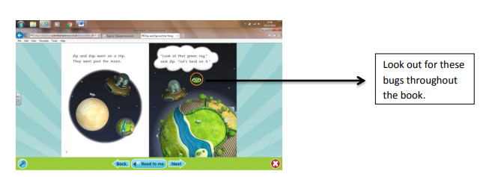

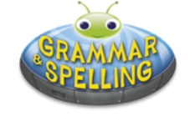
Literacy Grammar & Spelling This time click the Grammar & Spelling bug.
In this tab there may be a video to watch to explain a spelling rule and then games to play that are based on grammar or spelling strategies.
Literacy Writing – This week we are learning about adjectives – WOW words. We have talked about these words lots of times and have tried hard to put them into our writing every time. I would like you to watch the PowerPoint I have shared with you to remind yourself and then then look at the picture I have also shared with you. I would like you to write super sentences with amazing adjectives – Imagine yourself at the place, what do you see? What do you hear? Remember your capital letters and full stops! You could also ask an adult to take a photo of your work and upload it to your Hwb file. I am looking forward to seeing your work.

Topic – Time Capsule. Together, we are living through history right now. The Covid-19 pandemic has changed life as we know it, and it’s certainly a time to remember. As a family work together to create a time capsule to remember. I am really looking forward to seeing these and am getting my ideas together to make my own.

Science – Kitchen Science - Floating egg experiment. Have a go at the experiment I have shared with you in Hwb. Talk about your prediction, observe what happens and talk about your results. You can record your findings any way you like – photos/video/write up in j2e, poster etc.

Active – Garden Obstacle Course. My son and daughter had a great time creating their own obstacle course in our garden last week so I thought you would all like a go! This is a fun activity to get your family involved in. I have shared some photos of ideas with you in Hwb but don’t worry if you do not have certain items, you can use any equipment that you have e.g. trampoline, bike, skipping rope, slide, swing. You could even make your course easier or more challenging depending on which member of your family is completing it.

Outdoor Learning/Creative – This week we are combining our creative and outdoor learning lesson. Look around your garden to find some natural objects such as pebbles, twigs, leaves, flowers. Be creative and make an outdoor piece of artwork. I have shared some ideas with you on Hwb.

