Year 2 Home Learning
Week Beginning: 18.5.20
Year 2
Daily Do’s
Counting & Remembered Facts: Recall 2 times tables. Count back in 2’s from any given number
- Cymraeg: Scan the QR code for this week’s Welsh games. Also look at Pennard Primary’s Twitter page for more
Welsh games.
- Tricky words (Practice reading your level words-if applicable) PPT in (Hwb files - see resources section below)
Elmer Day 2020 – See Elmer Day information sheet
Monday | - Maths: Buried Treasure- Choose a level (support/core/extend/challenge)  - Literacy Reading: Bug club story 1 and click the ‘bugs’ to answer questions  - Health & Well-being: Elmer Day 2020– Listen to ‘Elmer’ complete ‘What makes you special and unique? (Hwb files - see resources section below)  - Tric a Chlic: Cam 1 - Gwyrdd Sain ‘ch’ https://www.youtube.com/watch?v=ploPx0aD1DA
Tuesday | - Maths: Toy Shelves- Choose a level (support/core/extend/challenge)  - Literacy Reading: : Bug club story 2 and click the ‘bugs’ to answer questions  - Literacy : Elmer Day 2020– Collective Nouns PowerPoint and activity sheets (Hwb files - see resources)  - Tric a Chlic: Cam 1 - Gwyrdd Sain ‘d’ https://www.youtube.com/watch?v=ploPx0aD1DA
Wednesday | - Maths: Problem Solving- Nature Reserve & spin the mouse  - Literacy Grammar: Grammar & Spelling Bug: Conjunctions- Watch video and play 2 games  - DCF/Literacy: Elmer Day 2020–Elephant research  - Tric a Chlic: Cam 1 - Gwyrdd Sain ‘i’ https://www.youtube.com/watch?v=BgxxpcEAbX0
Thursday | - Maths:–Homework sheet 2.13  - DCF/Literacy: Elmer Day 2020–Elephant Presentation  - Tric a Chlic: Cam 1 - Gwyrdd Sain ‘ll’ https://www.youtube.com/watch?v=mkKlg3LXNdM
Friday | - Maths: Mastery challenge on Abacus – Recognising ¼ , ½ and ¾ turns  - Active: Elmer Day 2020: Jungle safari yoga https://www.youtube.com/watch?v=qMGn47lGm3U  - Creative: Elmer Day 2020: Milk Bottle Elmer (Hwb files - see resources section below)  - Tric a Chlic: Gwyrdd Sain ‘u’ https://www.youtube.com/watch?v=YCwioyHWgkM
Resources | Maths - https://www.activelearnprimary.co.uk/start  Literacy Reading, Grammar & Spelling - https://www.activelearnprimary.co.uk/start  Tricky Words, Elmer Day 2020. – Follow the pathway below.  Hwb J2e my files shared files Year 2 Home Learning week 1

Year 2 Home Learning
Instructions
Daily Do’s – Counting & Remembered facts Each day spend 5-10 minutes on these counting targets.
I have also shared the PowerPoint we sometimes use in class to help if you find it useful.
Cymraeg Scan the QR code which will lead you to Quizlet where you can
practice and play games based on these Welsh patterns.

Tricky Words Spend some time each day to go over the words you are learning at the
Moment. Please move on when you are confident and can read the words out of
order too. I have included a PowerPoint for you to use if you wish. You can also play different games such as
snap/matching pairs/hunt the word

Tric a Chlic – To help you carry on learning the Welsh sounds we have been learning in our Tric a Chlic sessions in school, I have added a link to short video podcasts. Please enjoy revising the sounds.

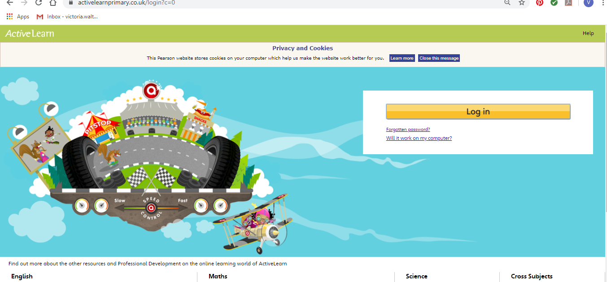
Maths – You will need to Log in to Active Learn to access the maths learning. Google Active Learn Primary then you can Log in to access your account. Your username and password were included in the Home Learning booklet sent out when school finished. If you are unable to find this, plea se let me know.

Once you are logged in, select the ‘My stuff’ tab and click on the abacus icon to find the maths work I have sent to you.
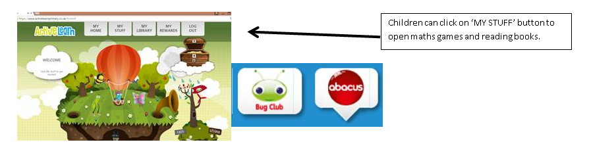

You will find maths games, activities and sometimes videos. For the main maths focus there are 4 different levels – support/core/extend/challenge. Please choose the appropriate level and challenge yourself to move to the next level the following day. For the interactive games you need to move through the levels – Bronze, Silver and gold. Once completed a level it will then unlock the next one. Sometimes there will be worksheets to complete. These can be printed, or you could have it up on screen and record on paper.
After completing your activities, you will win tokens which you can spend in the games zones.

If you have trouble launching the activities, check your pop up blocker is switched off

Literacy Reading– Again you will need to access the reading books I send you through Active learn. This time go to the ‘My stuff’ tab and select the ‘Bug Club’ icon. You will see a list of books that I would like you to read. To open a book just click and it will open on your computer screen. Throughout the book are ‘bugs’ to click on and answer some questions to earn points. When the bug is answered return to the book to complete it. At the end of the book you will be able to see if all bugs have been answered and then asked to add a smiley face depending on whether you enjoyed it or not.
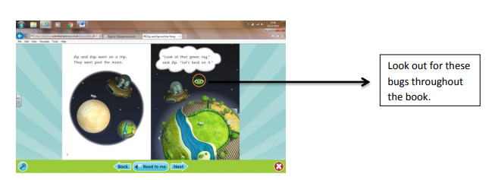

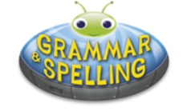
Literacy Grammar & Spelling This time click the Grammar & Spelling bug.
In this tab there may be a video to watch to explain a spelling rule and then games to play that are based on grammar or spelling strategies.

Literacy – Elmer Day 2020 - This week we are learning about collective nouns. I would like you to watch the PowerPoint I have shared with you and then complete the collective nouns activity sheet. Have you heard of any of these before?

Health & Well-Being – Elmer Day 2020 – During the story, Elmer realises that he likes being unique and special. What makes you special? Are you very good at doing something? Are you kind, funny or helpful? Draw a picture and write about what makes you special and unique.

DCF/Literacy: Elmer Day 2020 – I would like you to research and record facts about real elephants to share with me. I would like you to find out about their:
- Appearance
- Habitat
- Diet
- Young
- Any other interesting facts
You can present your research in any way. You could log into your Hwb account and produce an electronic version using any of the available packages (don’t forget to save your work in your ‘Home Learning’ file.
You could draw/paint/collage an elephant and write facts around it.
You could create a poster
You could also record your facts using the record button in JiT5

Active – Elmer Day 2020 Lets go on a safari through the jungle and explore the many different animals that live in the wild through the fun of yoga! We will see some elephants, trees, an eagle, lions, butterflies and all their yoga poses.

Creative – Elmer Day 2020 – Can you create a milk bottle Elmer?

