Year 2 Home Learning
Week Beginning: 27.4.20
Year 2
Daily Do’s
- Counting & Remembered Facts: Recall all pairs of multiples of 10 with a total of 100 e.g. 30+70, Count on in 10’s from
any given number
- Cymraeg: Scan the QR code for this week’s Welsh games. Also look at Pennard Primary’s Twitter page for more
Welsh games.
- Tricky words (Practice reading your level words-if applicable) PPT in (Hwb files - see resources section below)
Monday | - Maths: Number Puzzle- Choose a level (support/core/extend/challenge)  - Literacy Reading: Bug club story 1 and click the ‘bugs’ to answer questions  - Science: Stages of human growth PPT and activity sheet (Hwb files - see resources section below)  - Tric a Chlic: Cam 1 Melyn Sain ‘e’ https://www.youtube.com/watch?v=mqhFB7xXy4s
Tuesday | - Maths: Number Puzzle- Choose a level (support/core/extend/challenge) Move on from yesterday!  - Literacy Reading: : Bug club story 2 and click the ‘bugs’ to answer questions  - Outdoor Learning: Spring Flower Hunt - PPT and checklist (Hwb files - see resources section below)  - Tric a Chlic: Cam 1 Melyn Sain ‘c’ https://www.youtube.com/watch?v=5fETyBQbq0s
Wednesday | - Maths: game – Treetop Topple can you get to GOLD! & Homework sheet 2.12  - Literacy Spelling: Grammar & Spelling Bug Spelling: -le, -el, -al, -il– Watch video and play 2 games  - DCF: Use JiT ‘Paint’ in Hwb. Use the tools to draw your favourite spring flower. Can you label it too?  - Tric a Chlic: Cam 1 Melyn Sain ‘r’ https://www.youtube.com/watch?v=PtpwOZX46Ec
Thursday | - Maths: Problem Solving – Spot the difference See Hwb file for printable dominos if needed.  - Literacy Writing: Mr.Wolf – look at the picture, read the story starter, use your imagination and write the rest of the story. Could you also draw the character inside the tree? (Hwb files - see resources section below)  - Active: Spell your name workout!  - Tric a Chlic: Cam 1 Melyn Sain ‘y’ https://www.youtube.com/watch?v=uLRdSMyifDo
Friday | - Maths: J2blast – 2,5 and 10 times tables – Log in to your Hwb and select ttblast (see instructions below)  - Cooking: Funny Faces cooking activity (Hwb files - see resources section below)  - Health & Well-Being: Groups I belong to - PPT & design shield activity (Hwb files - see resources section below)  - Tric a Chlic: Cam 1 Melyn Revise all sounds https://www.youtube.com/watch?v=oDdaL_fVqTA
Resources | Maths - https://www.activelearnprimary.co.uk/start  Literacy Reading, Grammar & Spelling - https://www.activelearnprimary.co.uk/start  Tricky Words, Health & Well-Being, Literacy writing, Outdoor learning, Science, Cooking – Follow the pathway below.  Hwb J2e my files shared files Year 2 Home Learning week 1

Year 2 Home Learning
Instructions
Daily Do’s – Counting & Remembered facts Each day spend 5-10 minutes on these counting targets.
I have also shared the PowerPoint we sometimes use in class to help if you find it useful.
Cymraeg Scan the QR code which will lead you to Quizlet where you can
practice and play games based on these Welsh patterns.

Tricky Words Spend some time each day to go over the words you are learning at the
Moment. Please move on when you are confident and can read the words out of
order too. I have included a PowerPoint for you to use if you wish. You can also play different games such as
snap/matching pairs/hunt the word

Tric a Chlic – To help you carry on learning the Welsh sounds we have been learning in our Tric a Chlic sessions in school, I have added a link to short video podcasts. Please enjoy revising the sounds.

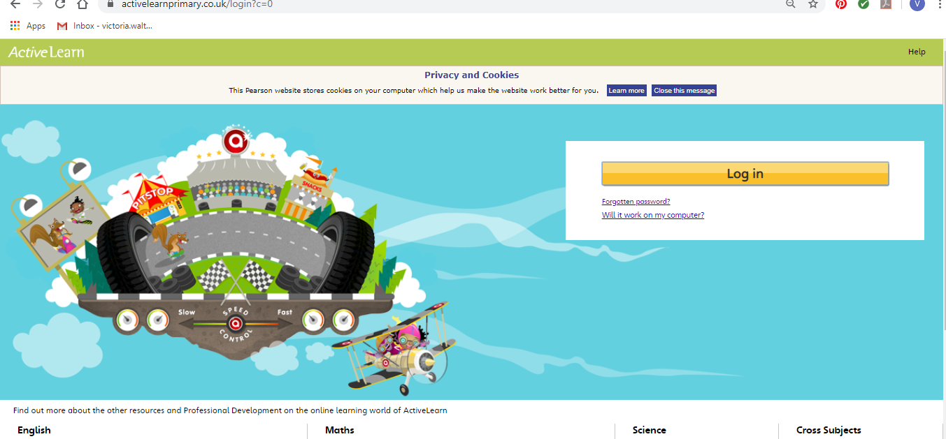
Maths – You will need to Log in to Active Learn to access the maths learning. Google Active Learn Primary then you can Log in to access your account. Your username and password were included in the Home Learning booklet sent out when school finished. If you are unable to find this, plea se let me know.

Once you are logged in, select the ‘My stuff’ tab and click on the abacus icon to find the maths work I have sent to you.
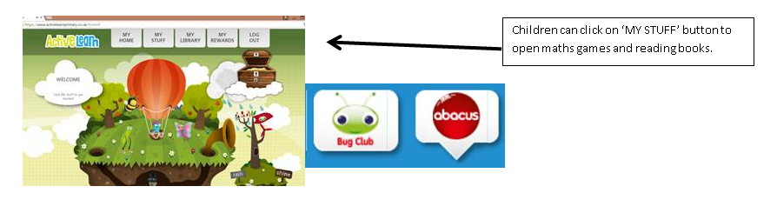

You will find maths games, activities and sometimes videos. For the main maths focus there are 4 different levels – support/core/extend/challenge. Please choose the appropriate level and challenge yourself to move to the next level the following day. For the interactive games you need to move through the levels – Bronze, Silver and gold. Once completed a level it will then unlock the next one. Sometimes there will be worksheets to complete. These can be printed, or you could have it up on screen and record on paper.
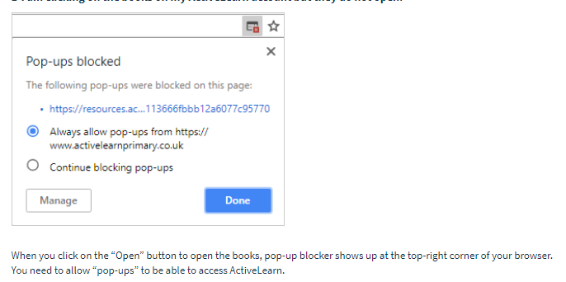
After completing your activities, you will win tokens which you can spend in the games zones.

If you have trouble launching the activities, check your pop up blocker is switched off

J2blast – This week I would like you to log in to Hwb and select the J2blast tile.

You then need to select the Ttblast icon to practice the 2, 5- and 10-times tables. Please move onto the next levels if you are confident with these. Level 6 and 7 are the 3- and 4-times tables.

Literacy Reading– Again you will need to access the reading books I send you through Active learn. This time go to the ‘My stuff’ tab and select the ‘Bug Club’ icon. You will see a list of books that I would like you to read. To open a book just click and it will open on your computer screen. Throughout the book are ‘bugs’ to click on and answer some questions to earn points. When the bug is answered return to the book to complete it. At the end of the book you will be able to see if all bugs have been answered and then asked to add a smiley face depending on whether you enjoyed it or not.
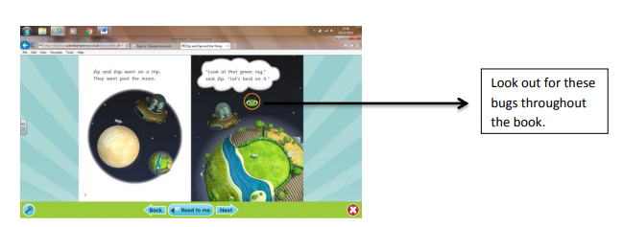

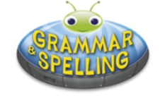
Literacy Grammar & Spelling This time click the Grammar & Spelling bug.
In this tab there may be a video to watch to explain a spelling rule and then games to play that are based on grammar or spelling strategies.
Literacy Writing – I would like you to do some creative writing this week. I have shared a story starter and picture with you called ‘Mr. Wolf’. Can you read the story starter and then carry the story on? Can you draw the character inside the tree? You can either write in your book, print out the sheets or write your story using ‘write’ in JiT. Remember to save it in your ‘home learning’ file if you do so that I can read it. You could also ask an adult to take a photo of your work and you can email it to me. I am looking forward to reading your stories.
I have put a marking grid in your folder to remind you what you need to include in your writing.
Science – This week we are learning about the stages of human growth from a newborn baby to being elderly. Please look at the powerpoint that I have shared with you on Hwb and then cut out the different stages and place them in the correct order. I would like to write some sentences describing each stage.
Health & Well-Being – I bet we are all missing our friends at the moment and going to the different clubs and groups we are a part of, I know I am. I would like to find out about the different groups you belong to. This can be inside and outside of school. I have included a PowerPoint to look at and discuss and an activity sheet for you to design your own shield. If you do not have access to a printer then maybe they could draw/write on paper instead.
Cooking – Funny Faces – you can be as creative as you like with this cooking activity! Make some funny faces using a variety of fruits, vegetables or foods that you find in your cupboard. We would love to see your creations so please take a photo and tweet it or email the photo to us!
Active- The name game is a fun fitness activity that you and your family can do together to have fun and get fit! First write out your name before doing the activity. Complete the activity listed for each letter. You could start with just jour first name and then challenge yourself to complete your full name. If you are looking for a real challenge, write your middle name or the names of each member of your family! I think it would be great fun to get other members of your family doing this too!
Outdoor Learning – This week I would like you to go on a Spring Flower hunt. Before you set off have a look at the Spring Flowers PowerPoint which I have saved in the shared folder on Hwb. Have you seen any of the flowers already? can you name them? With an adult Go on a Spring Flower hunt. This could be during a daily walk with your family or even in your garden. I would like you to record how many times you see each flower on your walk. I have provided a tally chart for you to complete. I wonder which spring flower is the most popular in your area? If the weather is not too good on this day, then please complete when possible.
DCF – I would like you to record the findings from your spring flower tally chart. Log into Hwb, go to JiT and Select ‘Chart’.
Select a blank template and enter the results into the table. You can then select a chart.
Remember to name and save your work in your ‘Home Learning’ file so I can look at it.
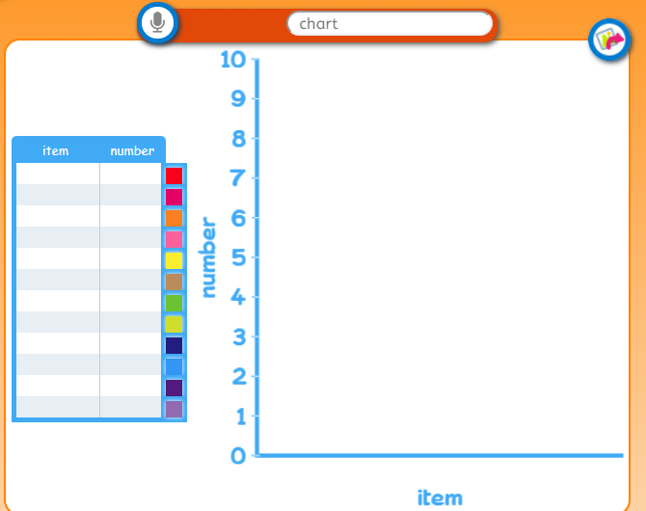

Parents - You can click the link to see a short video on the programmes available in JiT here https://www.j2e.com/help/videos/JIT

